**Top of Form**

**Getting Started with Git**

Often, as a data scientist or data analyst, you will be collaborating with multiple people on the same project: you get assigned one part, a colleague gets assigned another part, and so on. Imagine that you were working on this project locally, and you uploaded the folder to a centralized location regularly. If you aren't very careful, it would be easy for someone making changes to their section of the project to overwrite changes someone else had made when this centralized file was updated.

Version control systems solve this problem. These systems will "merge" changes together intelligently, enabling multiple developers to work on a project at the same time. While there are few distributed version control systems, including Mercurial, Bazzar, and Git, Git is by far the most popular.

In this mission, you start learning and using Git. Git is a command-line tool we can access by typing git in the shell. The first step in using Git is to initialize a folder as a repository, which tracks multiple versions of the files in the folder, enabling collaboration.

If you have heard of or used GitHub regularly, Github provides hosting for software development version control software using Git. Since GitHub uses Git, Git is paramount to learning as a data scientist. Not only will it assist you in a work setting, but it'll aid you as you build a portfolio and establish your online presence.

Installing Git

Before you start using Git, you have to make it available on your computer. Even if it’s already installed, it’s probably a good idea to update to the latest version.

Click on this link  [Git Guides - install git · GitHub](https://github.com/git-guides/install-git" \t "_blank)  to find the documentation on installing git on windows, MacOS, Linux. Download and install git by following the instructions diligently.

Creating a Git account

To begin to use git, you need to create a github account. If you already have a github account, feel free to skip this. To create a github account you need a unique username, email, and a password.  The username and password would be needed in subsequent sign in, so try not to lose them. Click the link below to create a new account.

[Join GitHub · GitHub](https://github.com/join)

Setting up Git

Before you launch Git, you need a little bit of setup first. You will probably do this only once since all the setup is stored on an external global file, meaning that all your projects will share the same configs. There is also a way to configure projects one by one, but we will consider this later.

Since Git is a distributed Version Control System, you will one day need to connect to other remote repositories. To avoid making any identity mistake, it is necessary to tell Git a bit about yourself. Don’t worry; it won’t ask a fun fact about you!

To set up Git, open “git bash" (for Windows systems) or the default console window (for Linux/MacOS or Windows systems that modified their PATH environment). In the command prompt, just tell Git your name and email address:

For windows just search and open “git bash" When you open “git bash", you should get something that looks like the image below.

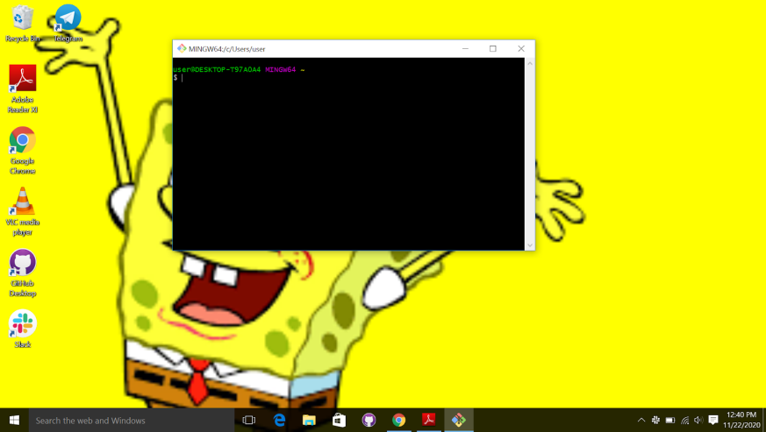

Figure 1: Git bash

Type the following code to set your username and email. Notice I used my username and email, you should change it to your own username and email.

 git config --global user.name "Zalihat"

 git config global user.email "[zalihatmohammad25@gmail.com](mailto:zalihatmohammad25@gmail.com)”

Notice the “global” argument; it means that the setup is for all future Git repositories,

so you don’t have to set this up again in the future.

Repositories

We will look at Github repositories, usually called “Git Repo.”

A repository is a storage where all your project and all the changes made to it are kept.

You can think of it as a “change database.” This is no cause for worry; it is only a typical folder on your system, it is therefore very easy to manipulate.

For each project you want to manage with Git, you have to set up a repository for it.

Setting up a repository is very easy. Just navigate to the folder you want to track, and tell

Git to initiate a repository there.

1. Create a folder
2. Navigate to the folder.
3. initialize the folder as a git repository.  You do this by right clicking on the empty space inside the folder and then selecting "git bash". This action will open "git bash". Run the command below to initialize an empty repository.

**Git init**

This will create a hidden folder git, to see this hidden folder on "windows" you go to “view” on the folder and check the hidden items, as shown below.

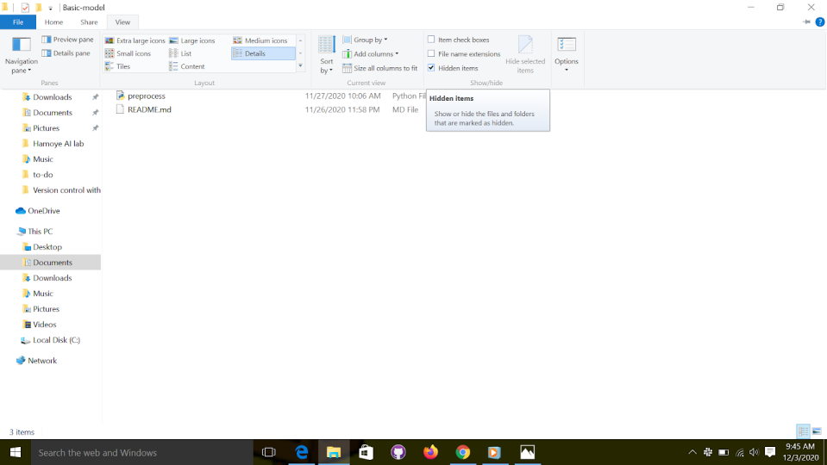

Figure 2: show hidden files

Working Directory

What about the empty area outside the “.git” directory? It is called the Working Directory, and the files you will be working on will be stored there. Generally, your most recent version will be on the Working Directory. Each file you work on is in the Working Directory. There is nothing particular about this place, except the fact that you will only manipulate the files here directly. Never modify the files inside the “.git” directory!

Git will detect any new file you will place in the Working Directory. You can also check the status of the directory by using the Git command “status.”

**git status**

Lets create a simple text file and name it “test.txt”, you can create this file using any text editor. save and exit.

Go back to "git bash" and run the "git status" command. Notice the change, that is because git noticed that the project has changed. Make sure that you place your new file alongside the .git directory like in figure below, not into it!

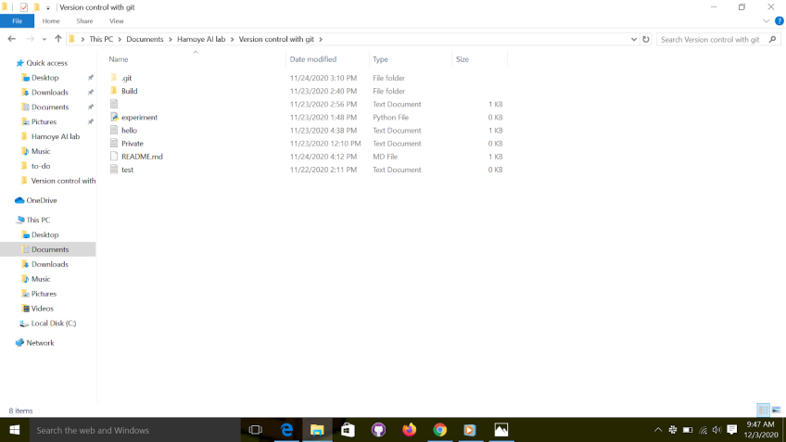

Figure 3: working directory

Staging Area

The Staging Area is where your files go before the snapshots are taken. Not every file you modified on the Working Directory should be taken into account when taking a snapshot of the  current state of the project. Only the files placed in the Staging Area will be snapshotted. Hence, before taking a snapshot of the project, you select which changed files to take account of. A change in a file can be creating, deleting, or editing. Think of it as designating which files get to be in the family photo. To add a file to the "Staging Area", we use the Git command “add.”

For example when we added the “test.txt” file and ran the "git status command", we  noticed this message;

Untracked files:

  (use "git add <file>..." to include in what will be committed)

     Test.txt.txt

This is telling you that you need to add the file you just created to the staging area so it can be tracked. Therefore, to add the file we go to the "git bash" and run the following command:

git add test.txt

This will add the “test.txt” file to the staging area, or if you created multiple files, you can add them one after another or together like “git add file1 file2 file3.” Also, if you want to track all the files added, you can run the command

git add .

Let’s check the status with git status command.

git status

Adding a file to the staging area won’t produce any visible result, but checking the status will get you a result similar to this:

On branch master

No commits yet

Changes to be committed:

  (use "git rm --cached <file>..." to unstage)

     new file:   test.txt

**Unstaging a file**

Say for example you made a mistake while staging the file, and you want to undo it, all you need to do is unstage the file.

Here is the command to unstage a file

 git rm --cached test.txt

Commits

Like we talked about in the section before this one, a commit is just a snapshot of the entire project at a certain time. Git doesn’t record the individual changes done to the files, it takes a picture of the entire project. In addition to the snapshot, a commit also contains information about the “author” of the content, and the “committer” or whoever put the change set into the repository.

A commit is identified by its name; a 40-character string that is obtained by hashing the commit. It is a simple “SHA1” hash so multiple commits with the same information will have the same name.

A reference to a specific commit is called “head,” and it also has a name. Also, the head you are currently working on is called “HEAD”. We can now commit the files we staged earlier. Before each commit, you should check the status of the Working Directory and the Staging Area. If all the files you want to commit are in the Staging Area (under the phrase “Changes to be committed”), you can commit. If not, you have to stage them with “git add.”

To commit all the changes we made, we use “git commit.” This will take a snapshot of our current state of the project.

git commit -m  “initial commit”

The command above will commit the changes made. Note that the “initial commit” is your commit message which could be anything. However, for the example, I used an initial commit because I want git and anybody that will access the repo to know that this is the initial commit.

The rule is to always use messages that are related to the changes made. For example, if I fixed a typo in the document, the commit message can be something like  “Fixed typo in test.txt”

Git Ignore

Not everything in the working directory should be tracked by Git. There are certain files (configs, passwords, bad code) that are generally left untracked by authors or developers. Those files (or directories) are listed in a simple file called “.gitignore.” Notice the period before “gitignore”; it’s important. To ignore files, create a file named .gitignore and list the files or folders to ignore in it.

Let’s get back to our repository. Imagine that you want to include a private, untracked file named Private.txt. You first have to create the .gitignore file using your favorite text editor and then write Private.txt.

How to create a .gitignore file on windows

1. Open notepad or notepad++ or any text editor available.
2. Type in the name of the file you want git to ignore e.g Private.txt.
3. Save file as; filename : .gitignore, save as type: all text

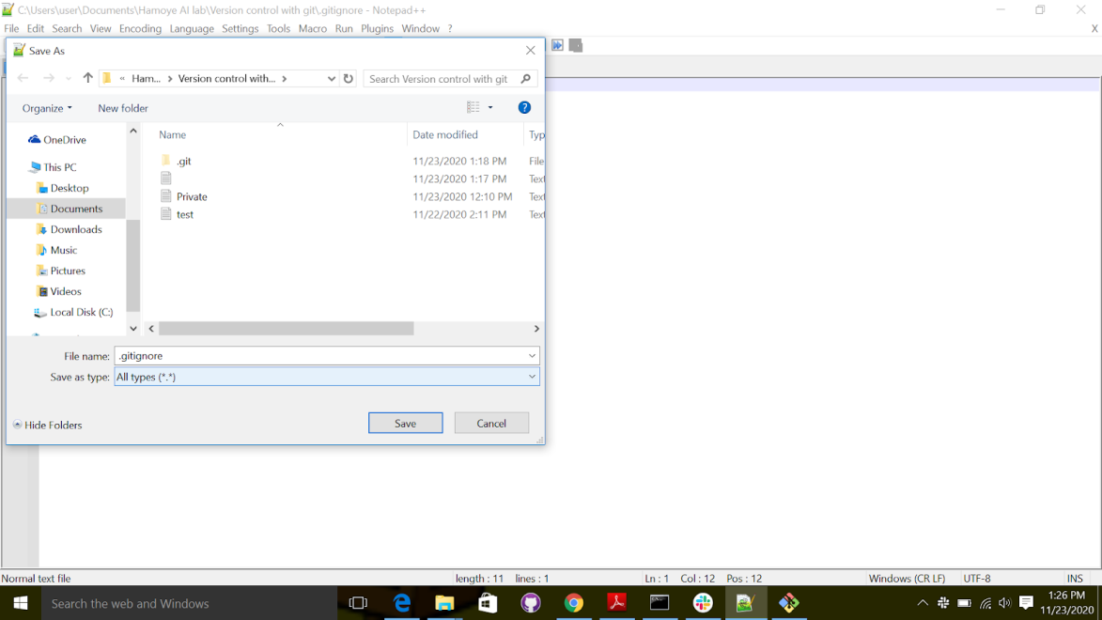

Figure 4: saving gitignore file

After saving the file, let's open the "git bash" to check the status. Note that if you want to open "git bash", click on the empty space on the folder. Once inside the folder, select "git bash" here.

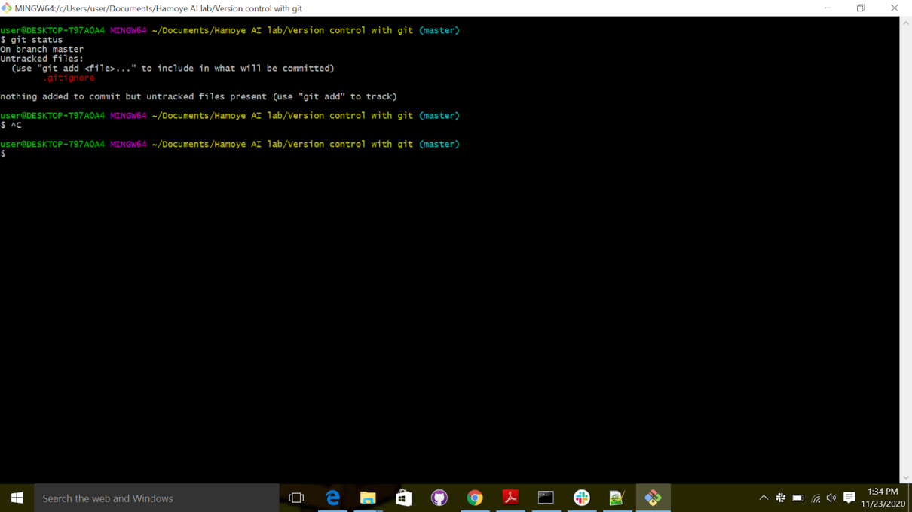

As you can see on the status shown in image above, Private.txt is not tracked. You can also see that the .gitignore file is tracked; you will therefore have to add and commit it after you modify it. We simply use the git add and git commands,

git add .gitignore

git commit -m "Added gitignore"

 As always, staging a file and then committing the project will result in a confirmation message summarizing the changes done.

[master a7c3285] Added gitignore

 1 file changed, 1 insertion(+)

 create mode 100644 .gitignore

Remember that the “.gitignore” global file should be placed at the root of your repository. If you put it in a directory, only the matching files in that directory will be ignored. Generally, having multiple “.gitignore” files in multiple directories is considered as a bad move unless your project is enormous. Prefer listing them into a single .gitignore file placed at the root of your repository. The .gitignore file doesn’t only ignore files listed by name; you can also ignore directories and files matching a description. You will find in the Table below, a handy reminder of all the templates you can use.

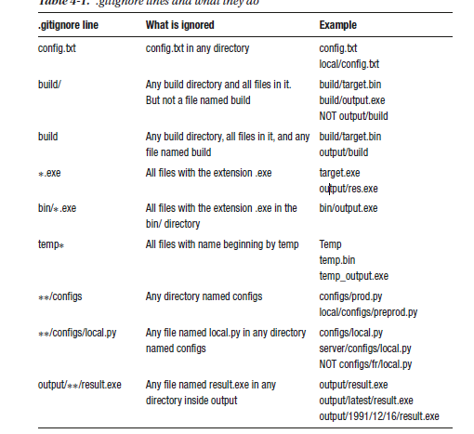

Figure 6: git ignore lines

That’s how you ignore files! It’s almost as easy as ignoring your responsibilities!

Notwithstanding, remember: the .gitignore file is tracked and versioned, so don’t forget to stage it before committing!

Let's look at another example:

1. create a folder and name it Build.
2. Add Build to the gitignore file.
3. Git status to check the status, make sure the build folder is not tracked
4. Git add .gitignore commit
5. Check status

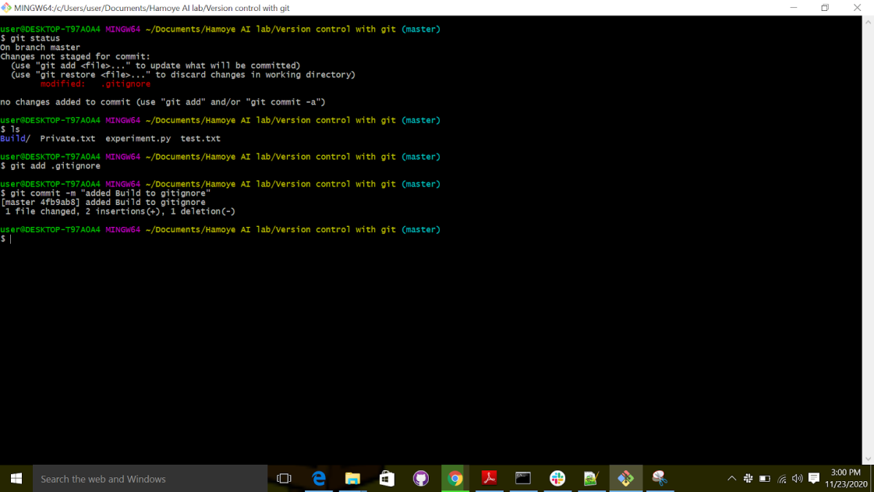

Figure 7: using the git ignore command.

Exercise:

Take your repository from the previous exercise and create multiple files and directories. Check Table 4-1 and try to ignore the files that you created using each line. Create as many files as you need, and don’t stop until you understand each pattern. No need to remember everything, but you should at least have an idea of when they should be used.

Checking logs and history

If you followed the exercises (as you should) or began to use Git for your own projects, you now have a little problem (that I promised would be solved easily with Git); how to consult the history log. This is one of the most used features of Git and also one of the easiest Git commands:

git log

Try it! Open "git bash" and run the command. You should get a view like the one shown below

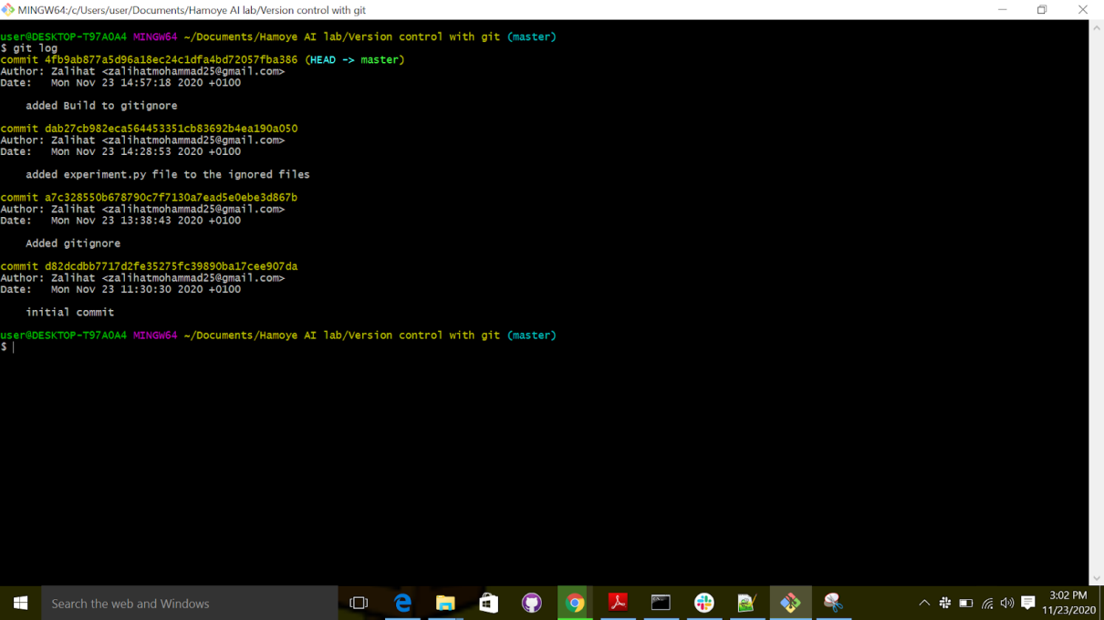

Figure 8:  git log

The commit log will list (from the most recent to the oldest) all the snapshots you or other people committed. It also includes, for each commit

• The name (unique, obtained by hash)

• The author

• The date

• The description

Since the commit names are too long, we will only use the first five letters as the

name. This will be important for the next section.

If your commit history is very long, you can use the keyboard and go

• Forward or backward one line: key up and down OR j and k

• Forward or backward one window: f and b

• At the end of the log: G

There are many parameters you can use with git log; The table below is presenting them to you.

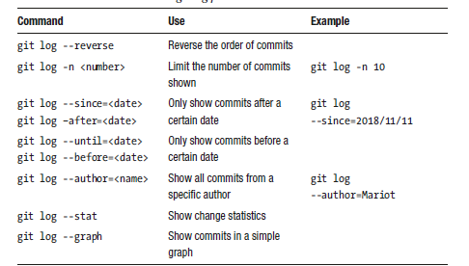

Figure 9: git log commands

Exercise:

This exercise is very simple. Just reopen your repository from the last exercise and check the

history log:

• In reverse order

• From yesterday

• For the last two commits

Commits

Tracked files can be in three states:

• Modified: You changed the file.

• Staged: You changed the file and prepared it to be snapshotted (git add).

• Committed: You took a snapshot of the entire project and the file was in it (git commit).

Navigating between versions

Many times, you will want not only to know what has changed in your project, but you also want to see what state it was in, to see the snapshot you took. It’s easy with Git.

When you want to bring the previous state of the project to the working directory, we have to check out the commit with “git checkout.” Since this changes the files on the working directory, you have to make sure not to have any unstaged files on there. Untracked files are fine since Git doesn’t track their states yet.

To check a snapshot of the project, we use the “git checkout” command, and pass the commit name as a parameter.

Remember the commit names we talked about earlier? We are going to use them in this section to switch between versions.

First you need to create a text file “hello.txt” , in the file write Hello world!, save and exit.

Open "git bash" inside the folder created earlier, use git status to check the status of the repository, git add to stage the changes and commit to commit the changes.

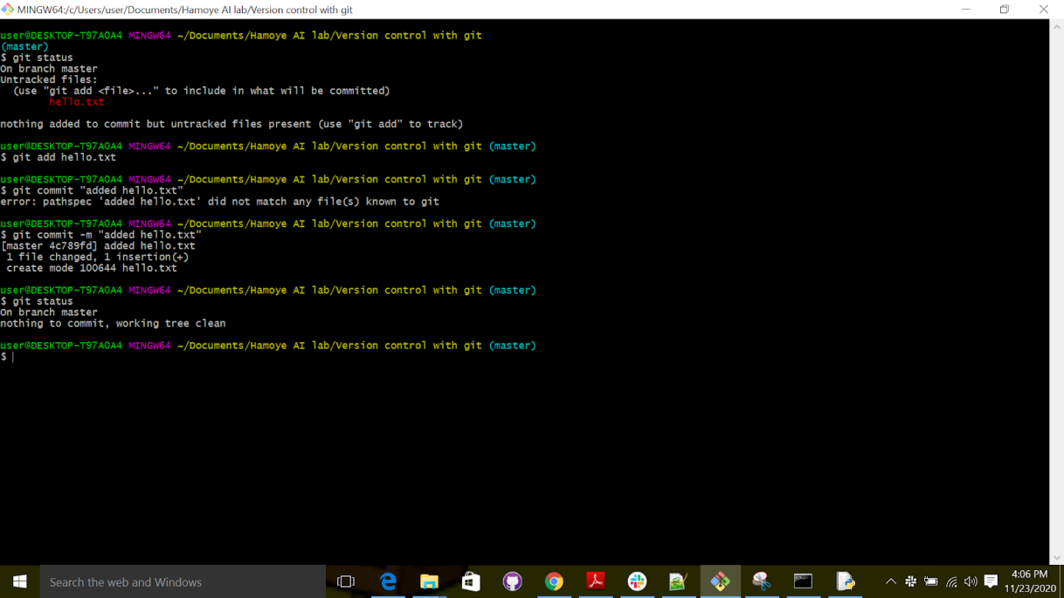

Figure 10: git commit

Now we want to edit the file and change the “hello world” to “Hello (add your name)” e.g Hello Zalihat.

After doing that, run “git add” to stage and “git commit”  to commit the changes.

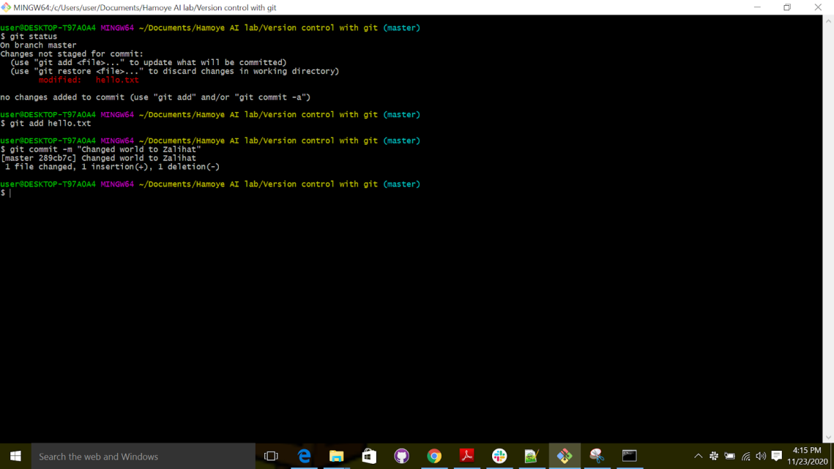

Figure 11: commit message

Nice, so now we want to switch to the time when the text was “hello world”.

We use checkout, followed by the commit name; to get the commit name we use the git log.

Remember you can type “clear” to clear your screen.

The question is, how do we know which commit to switch to? It's easy, just check the commit messages.

Git checkout 4fb9ab877a5d96a18ec24c1dfa4bd72057fba386

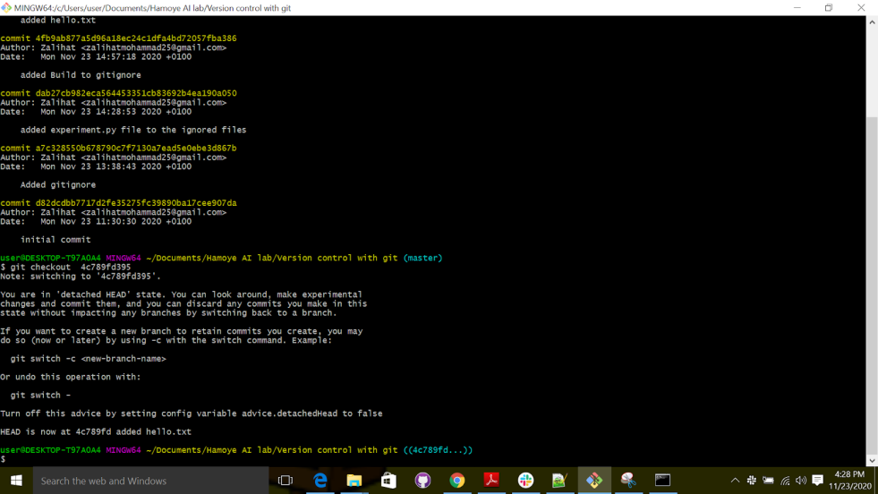

Figure 12:  switching between commits

If you check your text editor, you will notice that the project is now just like it was when you took the snapshot. That is what’s best with Git. Nothing you took a snapshot of is ever lost!

Now let’s learn some Git terminology. First is “head.” “head” is just a reference to a commit. Instead of saying “name,” when talking about commits, we say “head.”

When switching between different commits, we need a way to know which “head” we are on. The current “head” (the one being checked out) is just called “HEAD.”, and that’s it! A "head" is a reference to a commit (there can be multiple "head"s in a

repository), and the “head “pointing to the currently checked-out commit is called “HEAD”.

This is especially important when you make mistakes and want to return to the previous version.

### Remote Git

Since we started this course, we’ve only worked in our local repository. Still, Git is a great team working tool; it would be a shame to use it only on a local repository. We are going to see in this section what a remote Git is, and why anyone would  want to use it.

Using a remote server is just having a computer holding a copy of your project, and its history. You don’t have to push all your commits into it, you can just push the commits you want to share. Your coworkers then pull the commits that interest them and apply them to their own repositories. That does it! You work with a remote server to copy repositories and to push and pull changes. Let’s see in detail how it all works.

To set up a remote repository, you will first need a server capable of running the Git software. Any computer worth its salt can run Git as it is a very small software. You also won’t need a lot of firepower to run it properly. Even a very small computer like the Raspberry Pi is more than enough for Git.

Guess what? There is a tool that takes care of all those things for us! It is called GitHub! GitHub is the tool of choice when dealing with remote repositories; you can think of GitHub as a code hosting server for projects using Git. It works just like your own Git server, but with less headaches.

It was created in 2008 to host Git projects and is now a subsidiary of Microsoft, which has been investing a lot in Open Source Communities.

### GitHub and Open Source

GitHub has always been a close ally of Open Source projects; in fact, GitHub is home to the largest Open Source community in the world. Since developers need a convenient place to build and share their projects, GitHub is an obvious choice. That way, all of the decisions and discussions concerning the projects can be consulted and joined by anyone; and that is the beauty of Open Source.

With GitHub, the best thing you can do to an Open Source project is now easier than ever: contributing. When you spot a project that you like, you can follow it, like on social media, and see its progress. If you want to work on a new feature or fix a “bug”, you just have to make a clone of the project and work on it. That process is called “Forking,” and it’s the backbone of Open Source projects. When you’ve made all the changes to your copy of the project, you can submit a “Pull Request” (PR) to the maintainer of the project. That means that you are requesting that the changes that you made be pulled and merged into the project. Other contributors will then review your changes and may request some additional changes. Instead of  communicating by email or instant messaging, all of this is done on GitHub. After all the parties are in agreement about the changes, the Pull Request is accepted, and your changes are now part of the project!

Of course, Open Source projects are more than code; they need docs, translators, community managers, maintainers, and so much more. You can contribute to projects by writing documentations and providing translations, or even reviewing the changes that other contributors made. Projects also need testers and people that can provide insights about the final products. They are projects that have millions of contributors, so community managers are needed. They are responsible for the wellbeing of the community, and are expected to enforce the internal code of conduct of the community.

Some contributors are tasked with welcoming and tutoring beginners, which is difficult but very necessary for any project.

GitHub was chosen by millions of Open Source projects because the workflow from idea to release is so easy and accessible. The concept of forking a project to contribute to it is the main driving force of any Open Source project. If you like a project but don’t like the direction it’s going; you can fork it and start your own flavor of the project. You will then be the maintainer of the new project, and others can submit Pull Requests to you if they want to contribute. Thus, everyone is happy! As previously established, Open Source projects need documentation and tutorials for beginners. For small projects, a text file (called README by convention) is enough.

The “README” file should present the project and convey the problems it solves.

#### Remote Repositories

Do you remember the github account you created earlier? Click here to login with your username and password [GitHub: Where the world builds software · GitHub](https://github.com/" \t "_blank)

#### Creating a remote repository

You GitHub homepage is pretty empty but we’re working on filling it with cool projects. At the right side of the page, you’ll see some trending repositories or news story; but we won’t go there yet

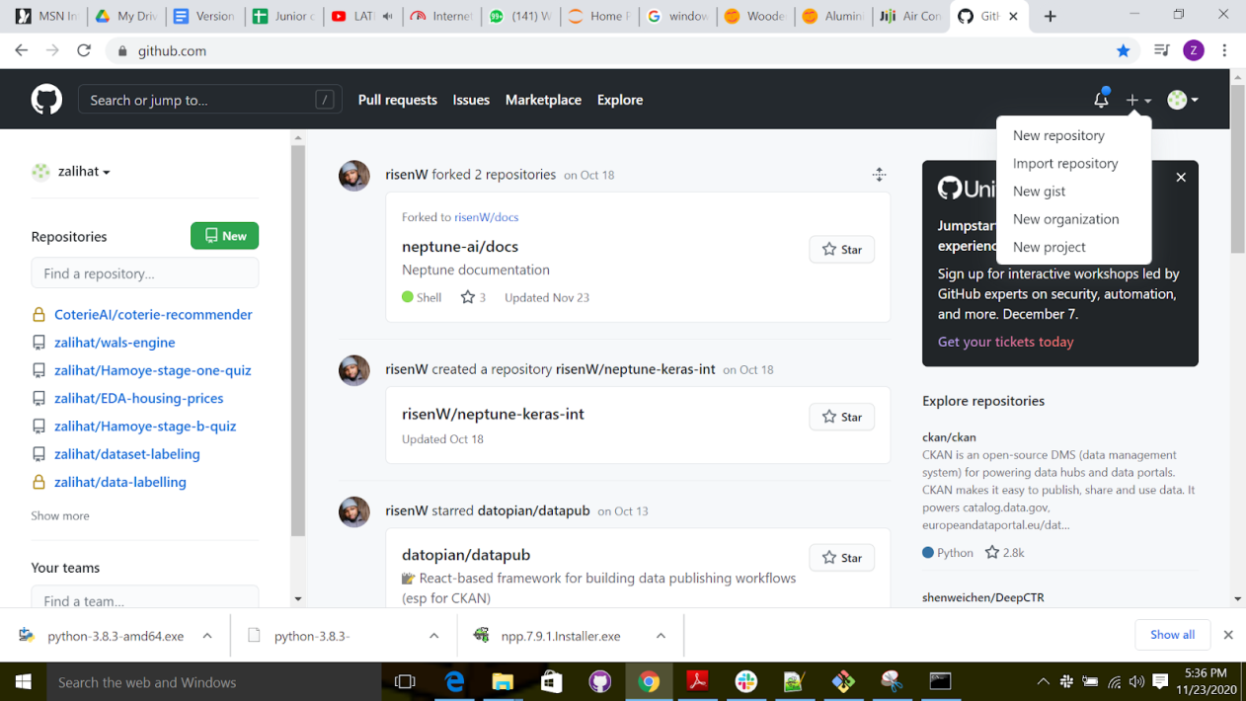

Figure 13: creating a remote repository

Click on new repository and you will see a page like the one below;

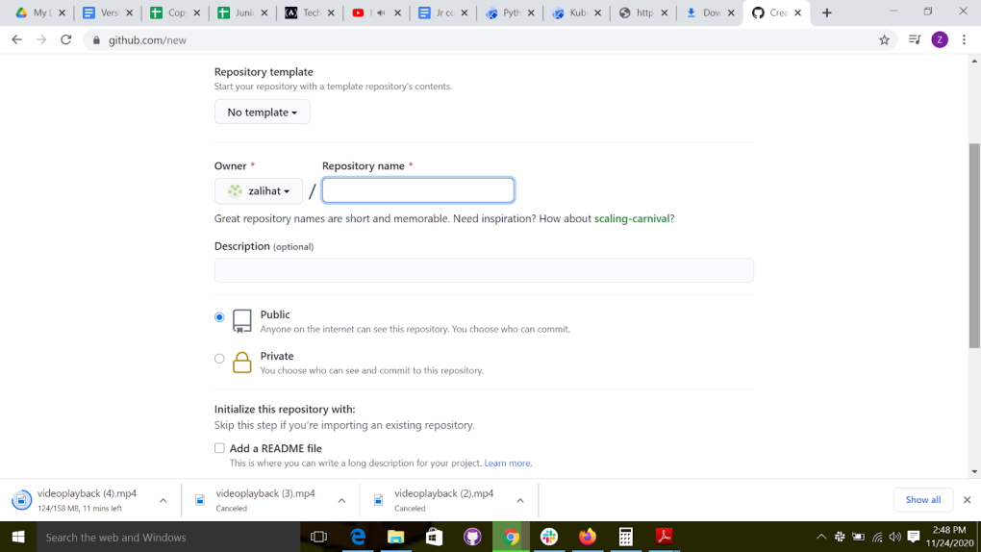

Figure 14: Create repository page

The repository for this example will be named “to-do”.

You can choose to make the repository private if you like, nobody but you will have access to it. A public repository doesn’t mean that anyone can edit it, it just means that anyone can read it and logged in users can propose changes to it. You will still be the maintainer of the project and the owner of the repository.

Then, you have the choice to initialize the repository with a README file. Ignore this for now because we are aiming to create a repository from scratch; and we will add

README, .gitignore, and license files later.

After all is done, click the Submit button to create your first GitHub repository! It’s that simple! You will then be redirected to your project page, which is a unique link to your repository. The link looks like this: https://github.com/your\_username/your\_repository; For example, the new repository I created is accessible through the following link: https://github.com/zalihat/to-do . Thus, you can’t create two repositories with the same name. Your project page should be similar to the one shown below.

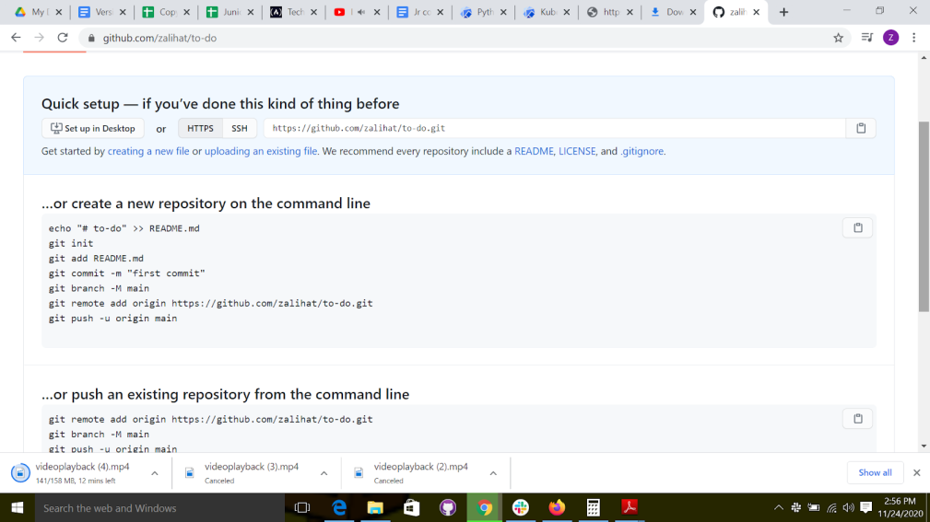

Figure 14 : new repo page

As you can see in the Figure above, there are some instructions on how to get started; whether you want to create a new repository or push an existing one. Since we are building our repository from scratch, we will go with the first option. The second option would have worked for us too because we already have a local repository, but we are going to ignore that from now on.

Thus, we created our first repository and are ready to push our project on it. Still, let’s look into the magic box to see what exactly has just happened.

Remember we earlier talked about remote Git, and how we decided to use GitHub as a remote

repository store? This section is a logical extension of that section because we are going

to learn how remote repositories managed with GitHub works.

When we created our repository using the GitHub web site, we gave instructions to GitHub servers and asked them to initialize an empty repository. Also, if you can remember, initializing a repository is very simple: go to any directory and execute git init. That’s exactly what happened here, except that this is not to your computer, but to a server hosted by GitHub.

It is therefore as if we executed the following commands on a faraway server which has git installed

1.  Create a directory to do

2.  Inside the folder "git bash" and run the “git init” command

It’s the same commands that we will use to create our local repository. So now, there

is a remote repository in GitHub’s servers that we will use to share our project.

Remote repositories are used so you don’t have to use your own computer to share your project. In the case of GitHub, the remote repositories are accessible by anyone, but

only the owner can edit them. We will discuss teamwork in a later section.

The main takeaway is that a remote repository is where you can publish your project and make it available to everyone. Also, anyone can clone your repository such that your advancements can be followed to get the latest changes.

Publishing your local repository to a remote one is called “pushing,” and getting the latest commits from a remote repository to a local one is called “pulling.” Push and pull are maybe the most used commands you’ll use in Git.

Even so, how can I tell GitHub which remote repository I want to be linked with my local one? That’s where the unique link to your repository is needed. You’ll use the link to push your local changes or pull the commits you don’t already have.

In conclusion, GitHub created an empty remote repository which can only be modified by you, but can be seen by everyone. What we need to do now is create a local repository, and link it to the remote one.

### Linking repositories

Now that we have our local repository, it’s time to link it to the remote! To list, add, or remove remotes, we will use the git remote command. For example, let’s link our current

remotes using this command:

git remote

You shouldn’t get any result because it’s a brand-new repository, and we haven’t linked any remote to it. Let’s add one now.

You will need the unique link to your repository to be able to link a local repository

to it; so, grab yours from the previous section. Mine is <https://github.com/zalihat/to-do.git> . Don’t forget the “.git“ at the end!

You will also need to create a name for your remote repository. That way, you can

have multiple remotes within a single project. It may be necessary in the case where the test and production remotes are different for each other. The default name is “origin” per

convention. Although you can choose any name, it is recommended to use origin as the

name of the remote where teammates share their work.

The command to add a link to a remote is simple. It’s

git remote add [name] [link]

Hence, to add a link to the newly created repository, you’ll have to execute this command:

git remote add origin <https://github.com/zalihat/to-do.git>

That’s it! You can check if the remote has been added by executing git remote or git

remote -v to get more information.

#### Pushing to remote repositories

We finally got our local and remote repositories linked. It’s time to push our project to

GitHub so we can share our work.

Pushing commits to a remote repository is very simple; but first, let’s create some commits to push. In your working directory, create a file called “README.md and put in the description of your project in Markdown. For example, here is my README.md file:

# TODO list

A simple app to manage your daily tasks

## Features

\* List of daily tasks

Now, let’s add the newly created file to the staging area by using git add.

 git add README.md

Now is the time to commit our project with git commit. As commit message, many developers choose “Initial commit” when it’s the first. It’s not a rule, and you can change it if you want to.

 git commit

Since we’ve done these many times already, you should be comfortable with staging and committing by now.

Just like that, we have our first commit! Now, we can push those changes to the remote repository. The command to push changes to remote is simple; you just need the name of the remote repository and the branch to be pushed. Since we haven’t created any branch yet (we’ll learn about branches in a later section), our only branch is called “master.” The git push command is

git push <remote\_name> <branch\_name>

So, in our case, the command will be git push origin master

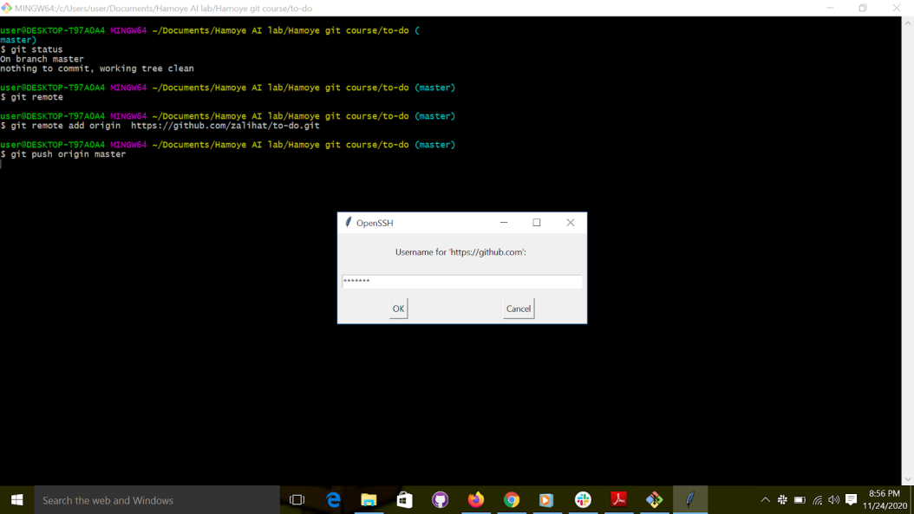

Figure 15: git push

You will be prompted to input your username and password for authentication. This is to ensure that you are the one making changes to the repository.

### Git issue

To successfully manage a project, any project, you have to plan in advance; just reacting

to new inputs and generally doing whatever you feel like is a perfect recipe for disaster.

A GitHub project is no different; you have to keep track of your actions before even thinking about doing them. That’s why GitHub has an awesome feature called Issues. We are going to discuss them in this section and learn how to manage them properly.

During all the sections of this course, you are both the developer and the project manager; but in a big project, you might not be included in the planning phases. However, for now, you are temporarily promoted to project manager and lead developer (in addition to being the only developer), congratulations! One of the duties of the project manager is to plan in advance all the tasks that need to be done. The plans don’t need to be very precise yet (in the real world they never are), but it is necessary to have a list of all the tasks that need to be done. Those tasks can be either new features, bug fixing, or just a team discussion. In GitHub, those tasks are called Issues.

An issue is used to track new feature development, bug fixing, or new ideas that a team member suggested. They are the brick and mortar of GitHub project management; in theory, no action should be done with an issue being attached to it. The aim of each action you take should be the resolving of an issue.

Long gone are the days where planning the next steps was done by boring team meetings; now you know exactly what will be your next steps, and most importantly, what everybody else is doing. Suggesting new ideas to your coworkers is easier than ever; just open an issue to discuss it with your team without using another app or email client. The biggest plus for using issues is that the history is kept forever—each feature, each bug, and each discussion.

### Creating an Issue

The best way to learn about issues is to directly interact with them. Therefore, let’s head back to our GitHub project page and deal with them.

When you open your GitHub project page, you directly arrive on the “Code” part of the project. It is the part where your project files are shown.

# todo add screenshots

Just below the project name are many tabs that show all the sections of your project. You will mostly work on “Code,” “Issues,” “Pull Requests,” and “Projects.” However, for now, let’s focus on Issues. Go ahead and click on issues  to begin. You should arrive at an empty section like the one shown below because your project has no issues yet.

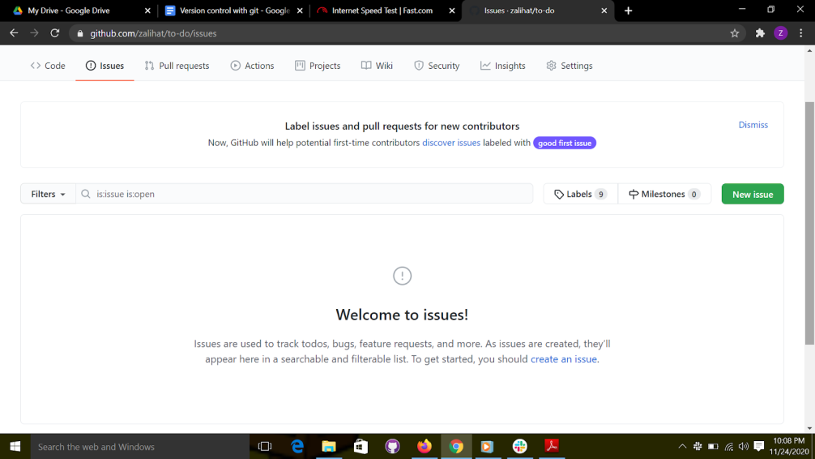

Figure 16: git issues

There are many calls to action there about creating a new issue. Click one of them, and you will see a form similar to mine as shown below.

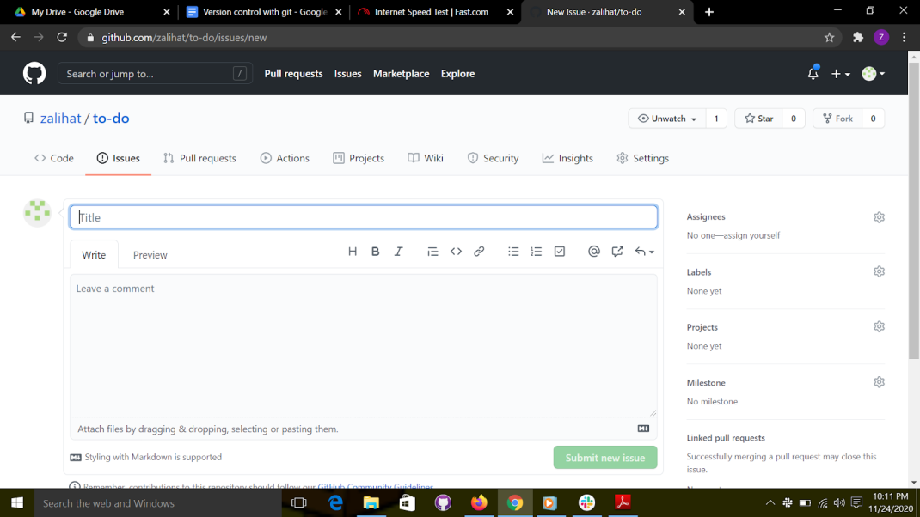

Figure 17: create a new issue

The form is pretty simple; and only the title is mandatory. There is also a comment section below the title, if you need more room to explain. Let’s go ahead and fill our first issue with the basic stuff; don’t change the values on the right side just yet.

For our first issue, we are starting a discussion about the technology we will use for our product. Issues aren’t needed for features and bug tracking only; they are also used to start a discussion and share ideas. Go ahead and fill your first issue like mine as shown below; I titled mine “Data collection”.

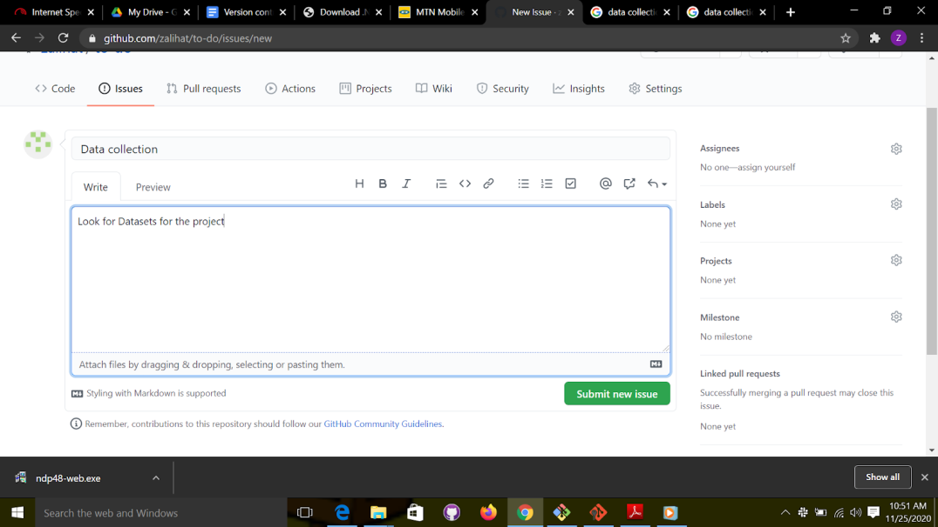

Figure 18: Git issue form

Now that we filled out the basic info about the issue, submit it. You will then be redirected to the detailed view of your new issue. It should be similar to my issue shown below,

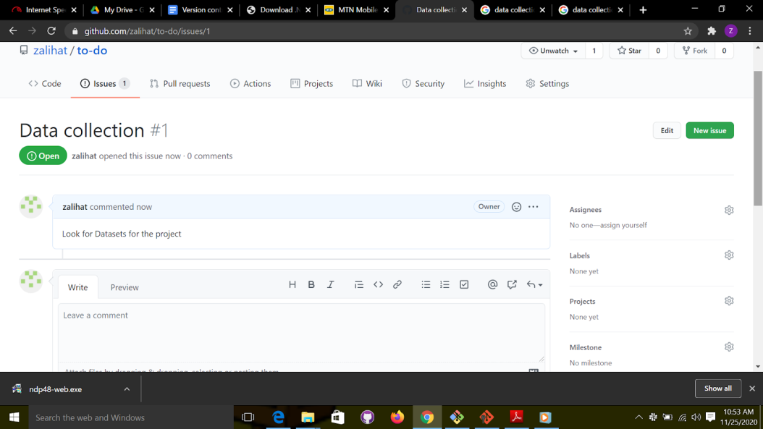

Figure 19: Detailed view of a git issue.

The first thing to note is that your issue has been given a number. Each issue has a unique number, and those numbers are not recycled. This  means that even if you delete an issue, its number will never be reused. This number is important, as you will see in this section.

The details page also includes a comment section where team members can discuss

the idea. It even includes a limited number of emojis that you can use as a substitute to

commenting. For example, if you agree with someone, giving them a thumbs-up is better

than commenting or writing “me too”! It would clog the communication and stall the

conversation.

At the bottom right side of the page is a “subscribe” button. If you choose to subscribe to an issue, you will receive notifications about the changes done to it. You will also receive new comments and news about milestones reached.

Since you are the only member of the team, you won’t do much discussion. Just add a comment or a reaction image and close the issue. Closing the issue won’t delete it; it will just mark it as completed. Deleting issues is not advised because keeping a history of the project is needed, and issues are the best way to keep track of changes. Also remember; if your repository is public, anyone can read your comments. Hence, please be kind and rewind any unpleasantries that might arise.

After commenting and closing the issue, you will go back to the issue details page, and it will look similar to mine as shown below,

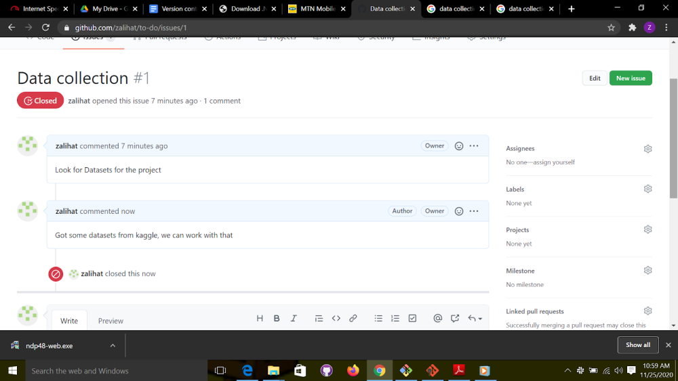

Figure 20: Closed issue

Interacting with an issue

Let's add more issues

1. Documentation
2. Data preprocessing.
3. Model selection
4. Building the model
5. Test model

Those are some basic steps that we will need to follow to accomplish our goal. Since you already know how to create issues, I will let you create an issue for each of these bullet points. After you are done, your Issues page should look like mine as shown below.

Before that, we can rename our repo from “to do” to something more data science. Bearing that in mind, I renamed mine to “basic model”, you can rename yours to anything you want.

To this just click on settings , as shown below, choose a different name and click on “rename”

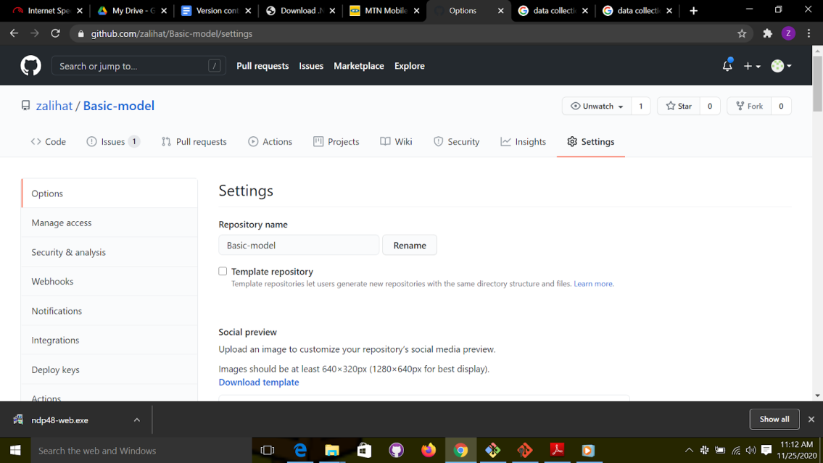

Figure 21: Renaming a repository

Your issue page should look like mine, as shown below,

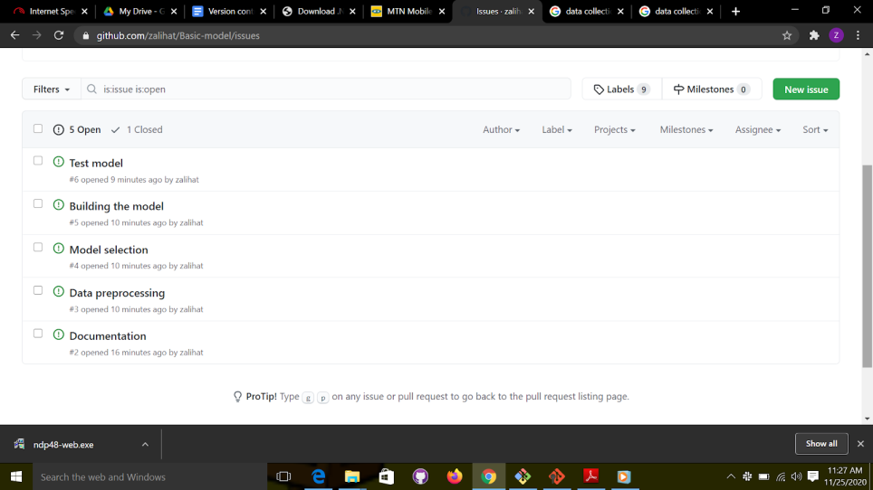

Figure 22: a list of git issues

As you can see, the tasks are shown in the order in which they were introduced. There’s also no way to distinguish them except for their numbers, and it’s very easy to get lost if there are too many issues. , to have a clearer look at all our tasks, we are going to use Labels.

Labels

Labels are exactly what you expect them to be: texts to help you quickly filter through your issues. Let’s use them directly so you can get familiar with the concept.

As you can see in the figure above, there is a search bar in the Issues page, and you can use it to filter through the issues. However, since we don’t have any labels yet, we can’t do any filtering; just basic search. Click the Labels button next to the search bar to show all the labels available. You will then see a list of the default labels that you can use; check the Figure below for an example of this.

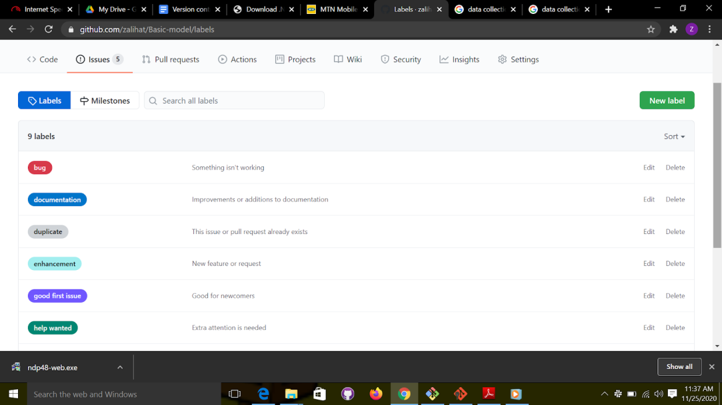

Figure 24: Labels

Those are the most commonly used labels in the developers’ community. Still, that doesn’t mean that they are mandatory or immutable; you can change them at will. Only when you are working on an Open Source project is it ill-advised to change them because most developers are used to them.

Since it’s your personal project and you are the project manager, you can add, edit, or remove any label you want. For example, the label “help wanted” will be useless if you work alone in a private setting. You can also use labels to tag the severity of the issue; many projects use labels like “urgent” or “breaking” if the issue is severe. Labels can also be used to differentiate the origin of the issue if the project is big enough. A big project can use the labels “frontend,” “backend,” or “database” to separate issues into groups.

After you made your changes to the labels (although I recommend to only add the new that you need and leave the default ones), get back to your issues and open the details page. Then, apply one or more labels on each one of them by clicking the Labels button. You can check Figure below for an example.

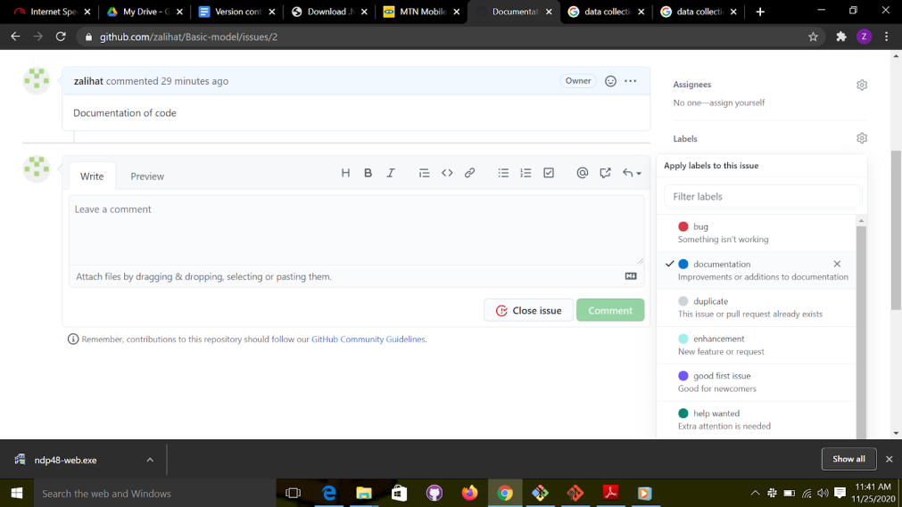

Figure 25: Labeling an issue

After you add the labels, a notification will appear on the comment section of the Issues page; you can check the figure below  for an example.

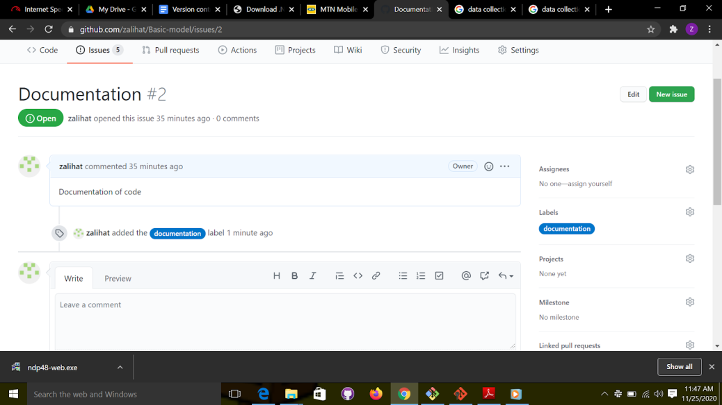

Figure 26: Notification about the newly added labels

Now, go through each one of your issues and apply some labels on them. Then, when you have finished, go back to the Issues page. It should look like mine (as shown below).

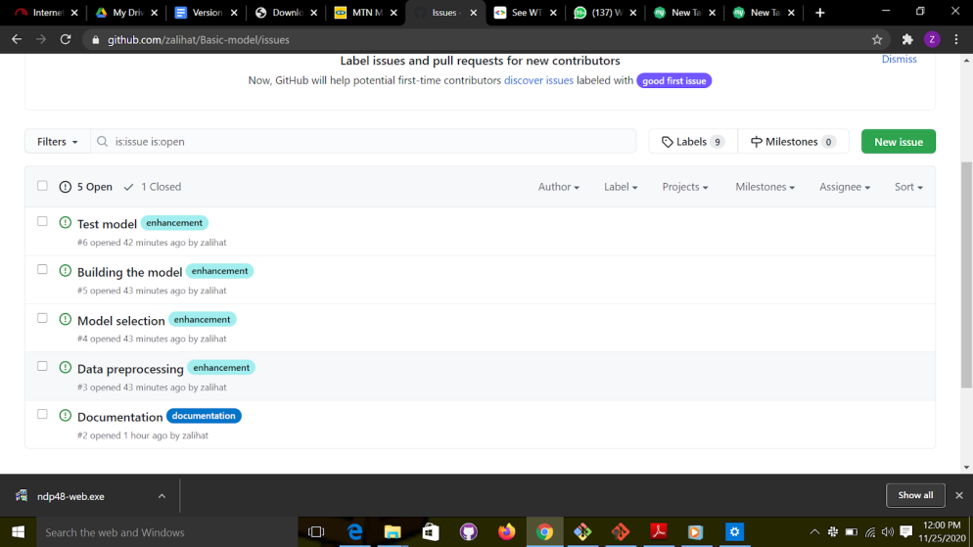

Figure 27: Labeled issues

Isn’t labeling  fun?! You know what is even more fun? Assigning issues to others! Let’s do it.

Assignees

Now that our issues are correctly labeled, it is time to assign them to a developer. It’s a fairly easy task , not so different from labels.

You can assign an issue to up to ten members of your team. However,  since you’re the only one right now, you can only assign yourself a task. Let’s do it!

Navigate to the issues titled “Data preprocessing” and “Model selection”, and assign them to yourself.

Assigning an issue to a team member works exactly like adding labels. You can check the Figure below for an example.

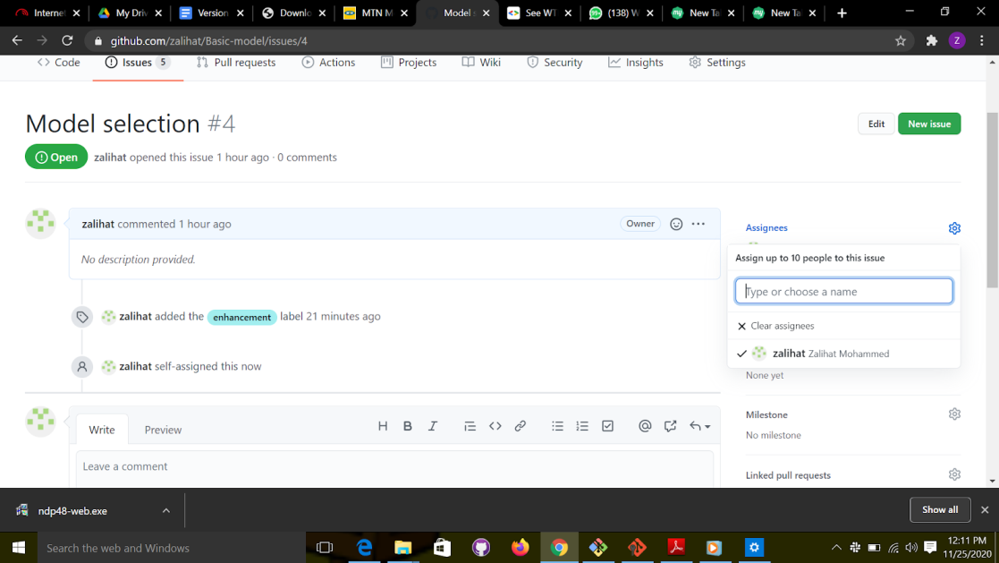

Figure 28: assigning people to an issue

After you assign those two issues to yourself, you will get a result like the one shown in Figure below on your Issues page. You can now filter through your issues by labels and assignees.

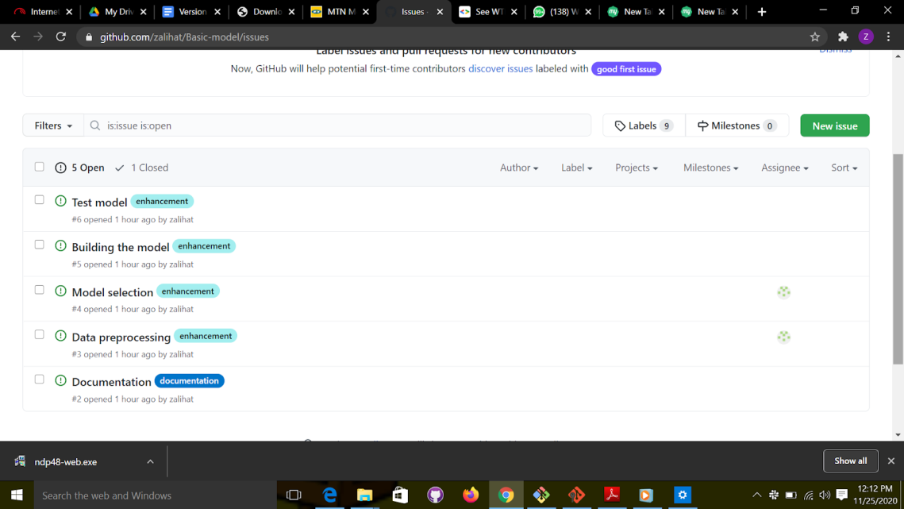

Figure 29: filter issues using labels

Git fork and git clone

The concept of “forking” and “cloning “is very important when we collaborate with other people to work on a project. Before you make changes to a repository, you need to have a copy of that repository saved, either locally or remotely. When you want to clone(copy) a project to your local machine, you use git clone and if you want to copy that repository to your own repository you use git fork.

Here are the guidelines for contributing to projects on github

1. Fork the repository, so you have a copy on your repository.
2. Clone the repository, so you have a copy on your local machine.
3. Make changes to it/ contribute to it.
4. Push it to your remote repository.
5. Send a Pull request to the owner of the repository.
6. If the owner of the repo is okay with your contribution then they will merge your changes with the original repository.

To "fork" a repository, login to your github account and search for the repository you want to contribute to. Then click on “fork” and it will ask which account you would want the repository to be copied to

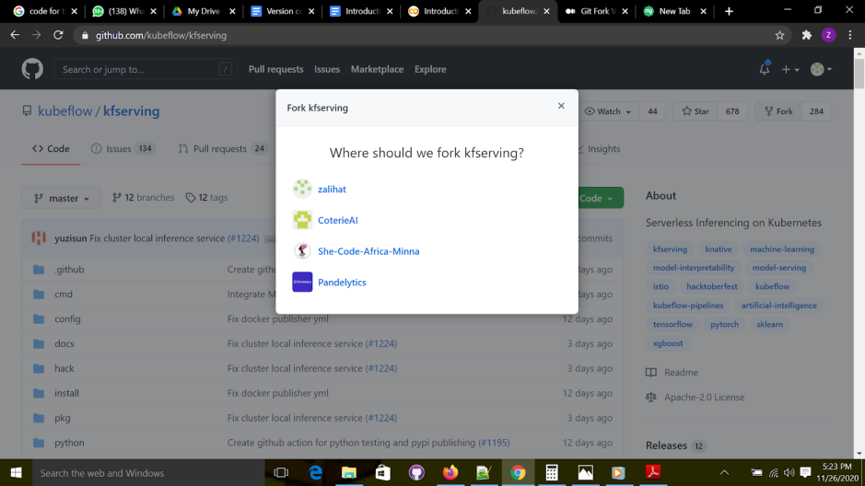

Figure 30: “forking” a repository

You will select the repository,  which will lead you to something that looks like this,

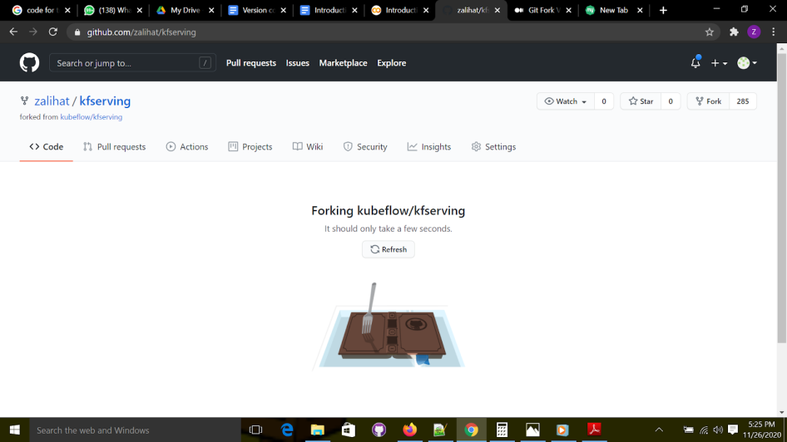

Figure 31: “forking” a repository

When this is done, you will find a copy of the repository in your account.

The second step is to copy the repository to your local machine. Here are the steps:

1. Go to your remote repository and copy the link as shown below;

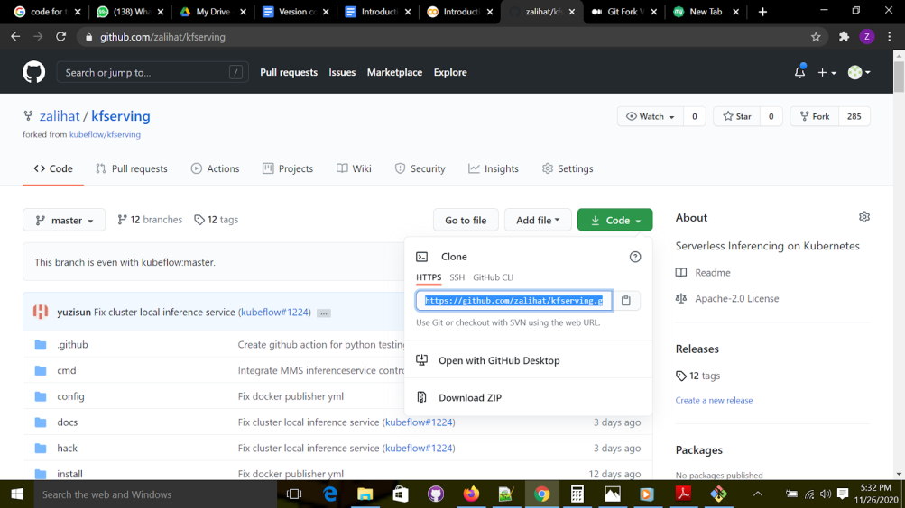

Figure 32: Copying the repository’s url.

**2.**Go to the folder in which you want to clone the repository, and open "git bash". Run the command below to clone the repository to the folder

Syntax;

git clone url

Example:

git clone https://github.com/zalihat/kfserving.git

Note that to paste the url, use insert, copy the url to clipboard, and type git clone. Then click insert.

Now you have a copy of the repository that you can make changes to.

Branches

In this section, we will talk about the most common way that developers use GitHub.

Keep in mind that each team has its own way of doing things, but each of these ways of

working is inspired by the basic workflow that they are going to present.

Remember the little fact about making mistakes? This omnipresent possibility of mistakes is why you need to follow this GitHub workflow, such that even if mistakes occur, you can  isolate their repercussions in a controlled manner. Our way of work from the previous chapter was to commit everything directly to the main project, which is very dangerous. The main project is most of the time the “production” line, the version that the clients see and use. Therefore, this version must be very clean and should always be exploitable. If any error makes its way to the main version, the clients will experience bugs and it will disrupt every team member’s work.

One way to resolve this issue is to create a copy of the main project and work on this clone. Each change you make to this copy will not affect the main project, so none of your mistakes can impact clients. Also, when you (and other people) are perfectly sure that the changes made resolve the issue, you can reproduce those changes in the main version.

How to create a branch

To create a branch, use the git checkout command. For example, let's say we are working on a model for predicting the weight of a baby. We do not want to make changes to the main branch till the changes are reviewed and approved  by everyone on the team. Here is what we will do; Remember when we talked about github issues? We said you could create different tasks(issues)  and assign them to members of the team. We create issues for each task, task may include, data collection, model training, etc. As a  result of this, one thing we can also do is to create branches for each of those issues.

Syntax:

git branch branch-name

Example; we can create a branch for the data preprocessing by running this command;

 git branch "data-preprocessing"

To check if the branch has been created, run the command;

git branch

This will give a list of all the branches on the repository, as shown in the figure below:

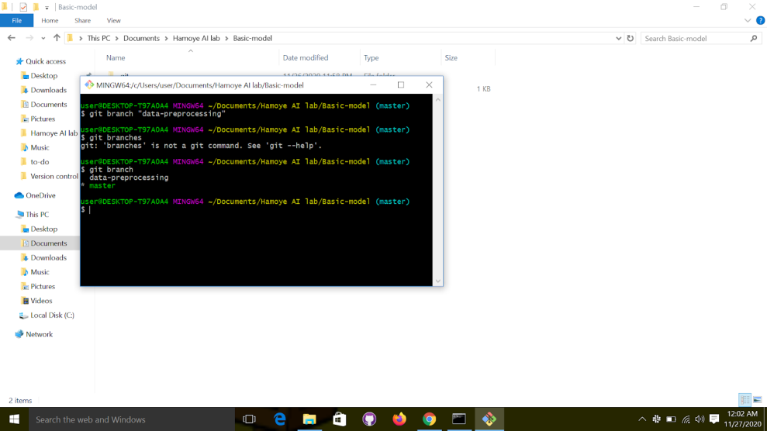

Figure 33: list of “branches”

Before you can make changes to a branch, you have to switch to it**.**

Switching to another branch

You already know the command to switch between versions. Well, we will use the same command to navigate between branches. Simply use “git checkout” with the name of the branch as a parameter.

Therefore switch to the data-preprocessing branch created earlier. Remember you can always use the git branch command to  get a list of all current branches, if you forget the branch’s name.

 To switch to the branch, run the command;

git checkout data-preprocessing

You should get something similar to this

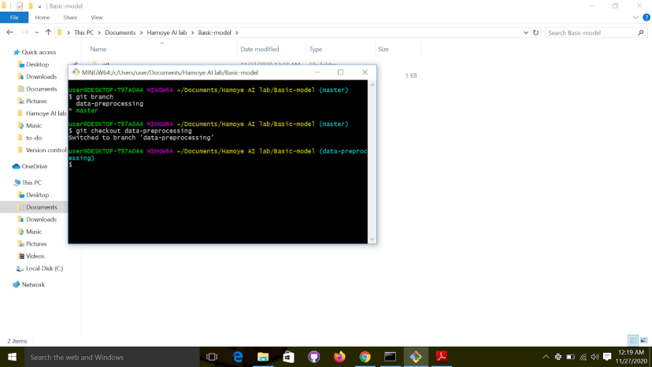

Figure 34: switching between branches.

Now that you have created and switched to the data preprocessing branch, let’s try something fun:

1. Using the basic model repo
2. Open "git bash"
3. Create and switch to the data-preprocessing branch.
4. On this branch lets create a processing.py file using any text editor.
5. Save and exit
6. Stage and commit changes
7. “Push” “branch” to the remote repository. To do this, run the command;

git push origin data-preprocessing

Syntax is git push origin branchnam

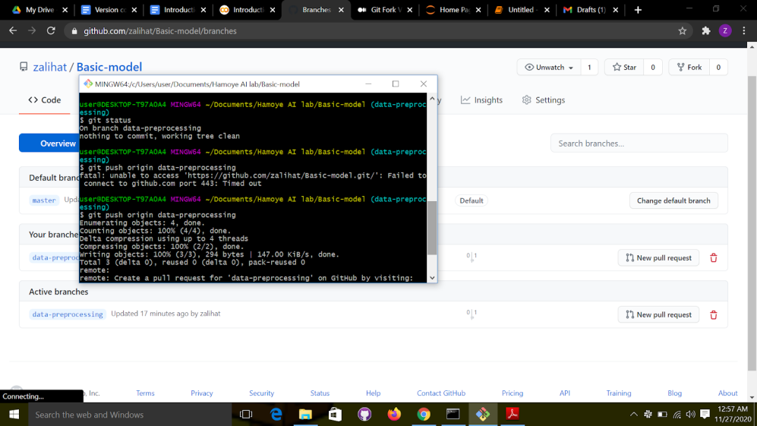

Figure 35: pushing a branch to a remote repository

If you check the remote repository, you will see that there are now two branches available; the master and data-preprocessing branch.

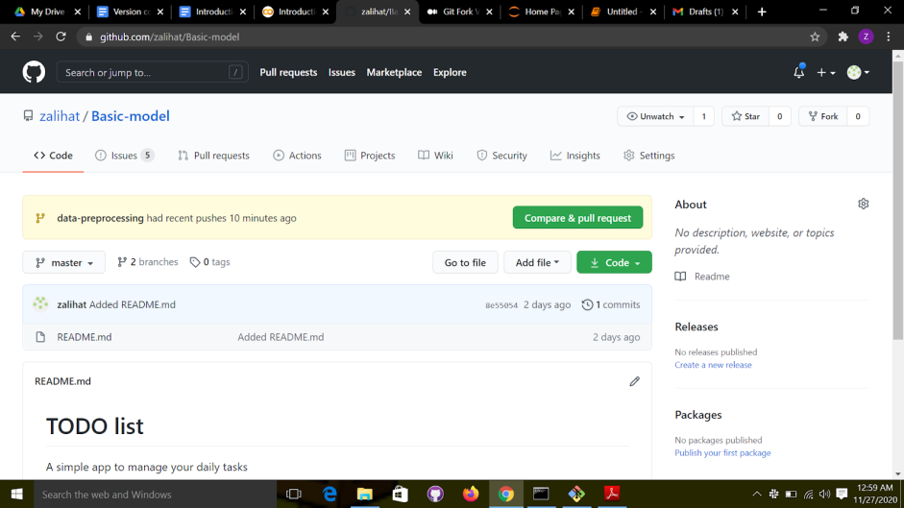

Figure 36: Remote repository’s branches

Here is the cool part, if you switch back to the master branch, the preprocessing.py file will not be there. The reason is that the changes were made to the branch created, not to the main project. How then do we bring the two together? The answer is pull request, and merges.

Pull Requests.

Many developers who don’t follow a particular workflow say that it’s a waste of time and that it takes away precious development time. There is a truth in that statement, because following the workflow means waiting for other people to review your code. Even so, you have to keep in mind that you don’t have to wait around doing nothing. While you wait for a review, you can directly go on to solve another issue! That’s why branches are so powerful in Version Control Systems; you can work on multiple issues at the same time.

With the workflow, you can begin to work on an issue, ask for some ideas or directive from your peers, and then work on another issue while you await responses. After you receive the necessary feedback, you can continue to work on the first issue.  You may repeat this until the issue is resolved.

Pull Requests, as useful as they are, are a fairly easy-to-understand concept. Submitting a Pull Request, or PR, is just asking for permission to apply all the commits in a branch to another branch. All the same, we’re moving too fast. Before learning about Pull Requests, we have to learn what a “pull” is.

Pull

In Git terminology, a pull is just the opposite of push (give yourself a high five if you guessed that!). Push takes your branch and copies all its commits to a remote branch. It also creates the branch if it doesn’t exist on the server yet. Pull is just that, but backward; it looks at a remote branch and copies the commits on it to your local repository. It’s just an exchange of commits; push if it’s from local to remote, and pull if it’s from remote to local.

The syntax is very similar too:

git pull <remote\_name> <branch\_name>

For example, if you wanted to get the commits from the master branch on GitHub, you would have to execute the command while checking out the master branch:

 git pull origin master

In the last example, there is a new call to action on the page, right above the list of branches. It shows the name of the branch that you just created, and a big button for creating a PR. Click the button to continue; you should get to the Pull Request creation form, just like the Figure below;

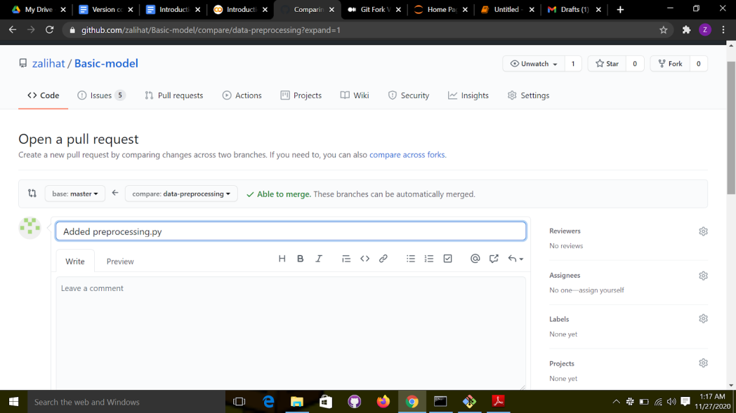

Figure 37: Pull request form

You can note that the PR creation form is very similar to the issue creation form.

On the right, you can find the same information about assignees and labels; they work exactly the same. On the bottom of the page, you can see the commits to be applied by the Pull Request; and if you scroll down, you’ll find the differences between the versions.

Check Figure below for an example of this.

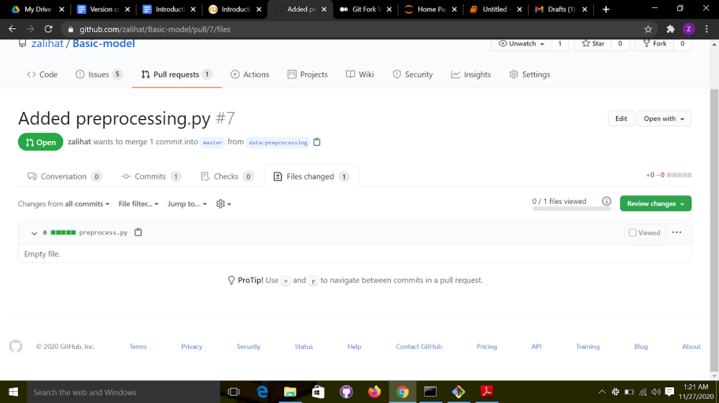

Figure 38: sample of a Pull request

After you create a Pull request, the reviewer can then review the changes. After the review, if the changes are great, the branch will be merged with the master branch.

Git Merge

The changes made to the data-preprocessing will only be on the branch until we merge the branch with the master branch. To merge the two branches, we use the git merge command,

To do that, run the command below;

1. Git status to check the status of the repository. As shown in the figure below, we are still in the data-preprocessing branch

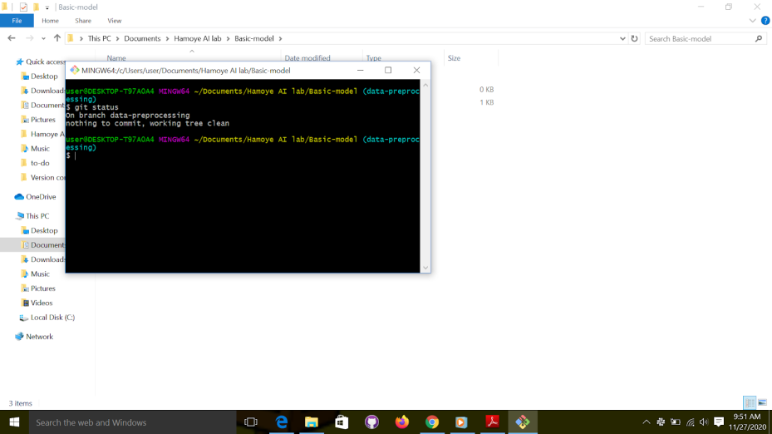

Figure 39: checking the status of the repository.

2. Run git log to check the project history.

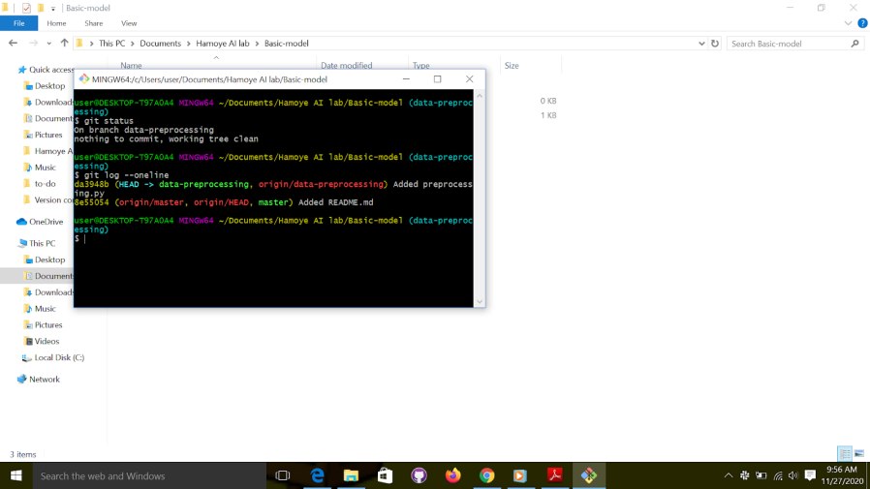

Figure 40: checking the project’s history

As shown in the figure below, we are on branch data-preprocessing and the branch has one commit.

Use the option “--oneline” when using git log to get a prettier result.

3. As you can see in the figure above, HEAD now points to the last commit of our new branch; which means that every commit we create will have that as a parent. You will also notice that the master didn’t change; that’s because we only worked on our newly created branch. Now that we are satisfied with our fix, let’s merge the branch to the master branch so we can test it. To merge our branch into master, we have to first check it out. Hence, switch to the master branch by running  the git checkout command.

4. Now let’s try to merge the branch into the master branch. Merging just means reproducing all the commits on one branch on another. To do so, we will use the “git merge” command, followed by the name of the branch being merged.

 git merge <name>

Since we are looking to merge “data-preprocessing” into “master,” ourcommand to execute on the master branch is;

git merge data-preprocessing

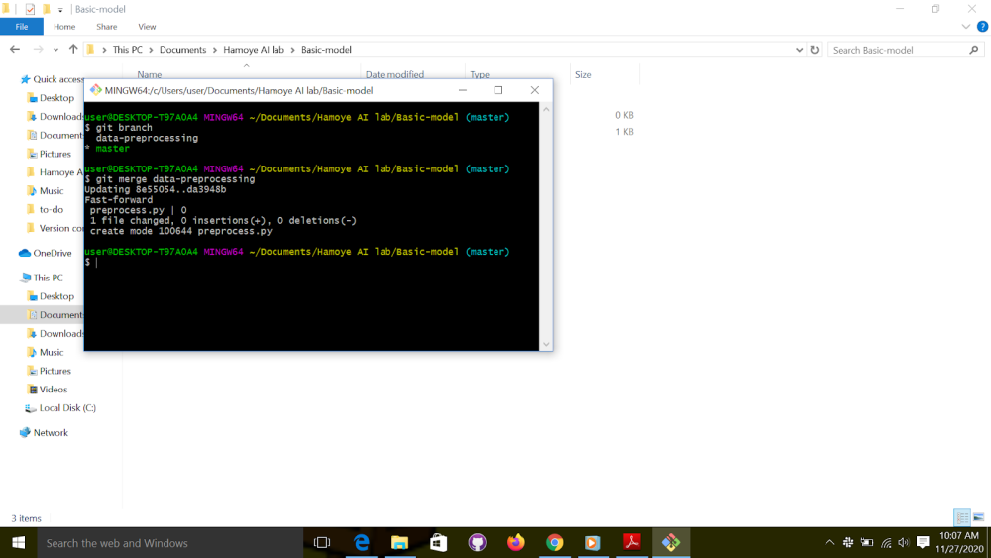

Figure 41: Git merge command

Let's check the history of the repository by running the “git log” command;

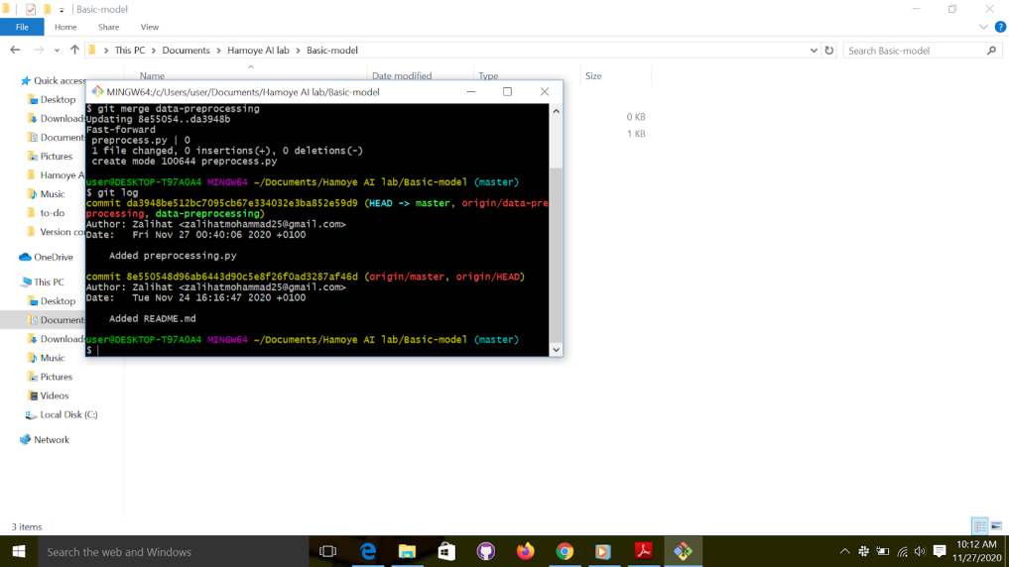

Figure 42: checking the project’s history

As you can see, “HEAD“ now points to “develop” because it’s the checked-out branch. You can also notice that master  and data-preprocessing  now point to the same commit; that’s because of the merge.

The changes made now are only on the local repository. Therefore, to push the changes to the remote repository, we use the git push command.

git push

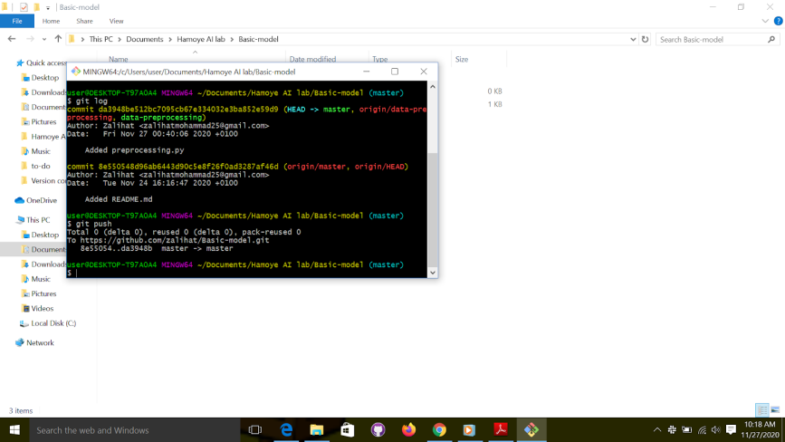

Figure 43: Push changes to the remote repository.

Now, check the remote repository to see if the changes reflected on it. It should look like this;

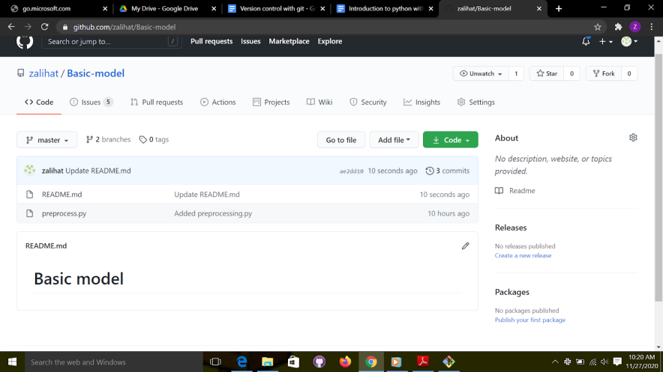

Figure 44: checking remote repository for changes made.

PROJECT 1

To put all we have learnt together, let's do a little project. Here are the instructions.

Activity 1

1. Create a  folder and name it whatever you want.
2. Run the “Git init” command to initialize the folder as a git repository.
3. Make changes to the folder; you can add whatever file you want.
4. Stage the changes using “git add” command.
5. Commit the changes with git commit.
6. Create a remote repository.
7. Link the local repository and remote repository.

Solution

1. Note that when you create the folder you have to open the folder before you do "git bash" as shown below; I am stressing this because a lot of people make this mistake, even experienced developers.

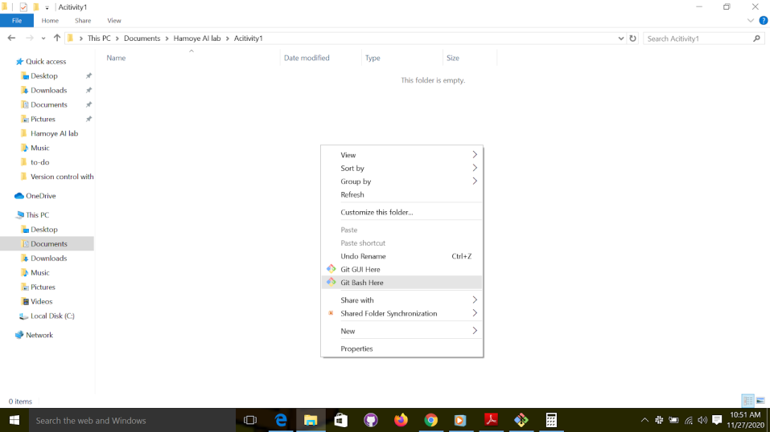

Figure 45: “git bash”

2.  Run the git init command

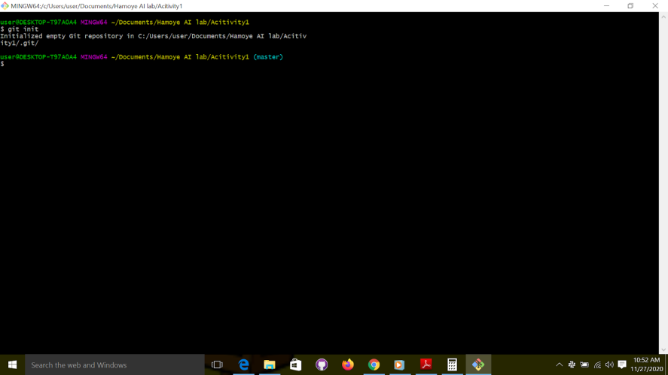

Figure 46: run the “git init” command

3.  Make changes

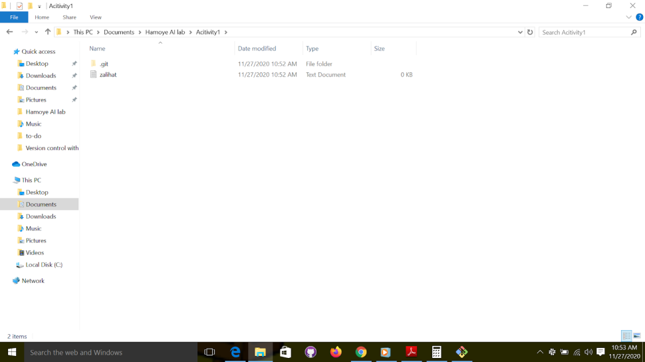

Figure 47: make changes to the repository.

4. Git status

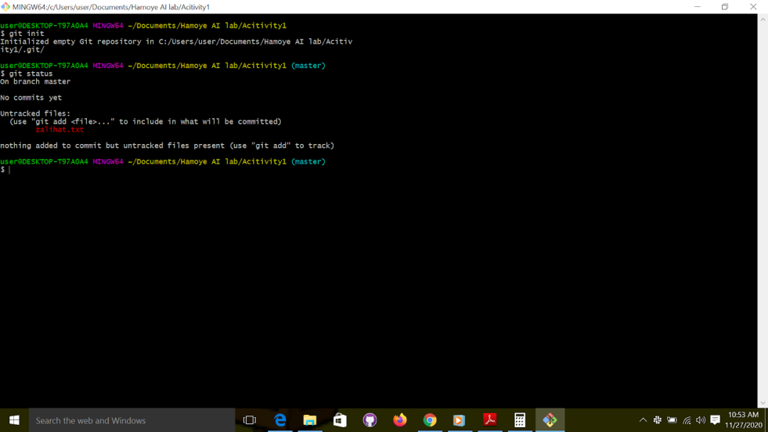

Figure 48: check the status of the repository

5. Stage changes, git add filename or git add . to stage all changes,

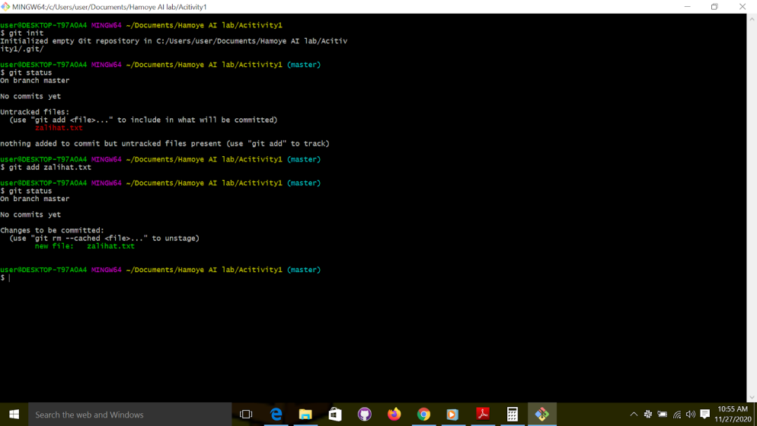

Figure 49: stage changes

6. Commit changes;

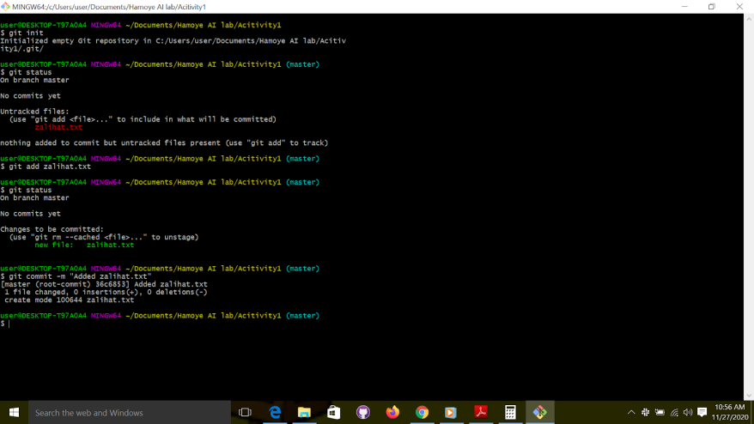

Figure 50: Commit changes

7. Create a remote repository and name it the folder name.

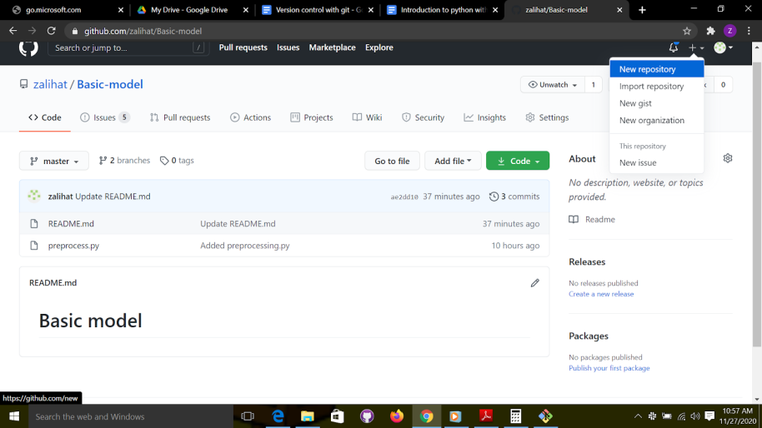

Figure 51: create a remote repository.

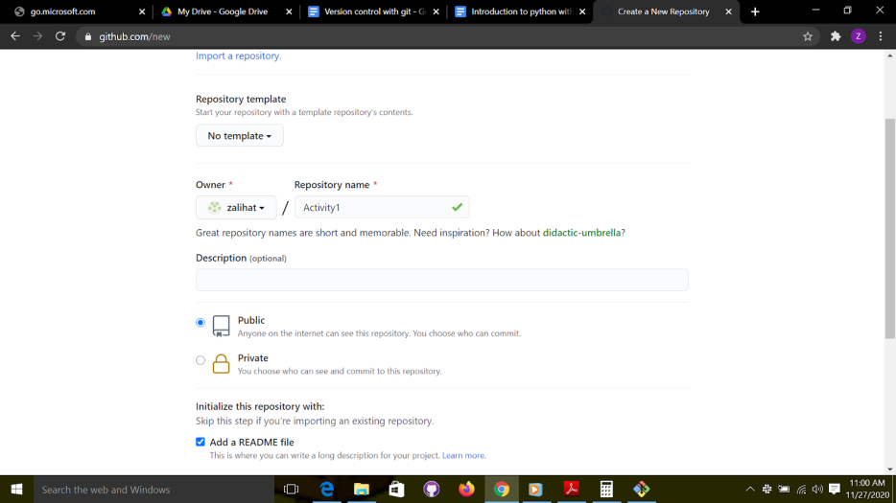Figure 52: Name the remote repository

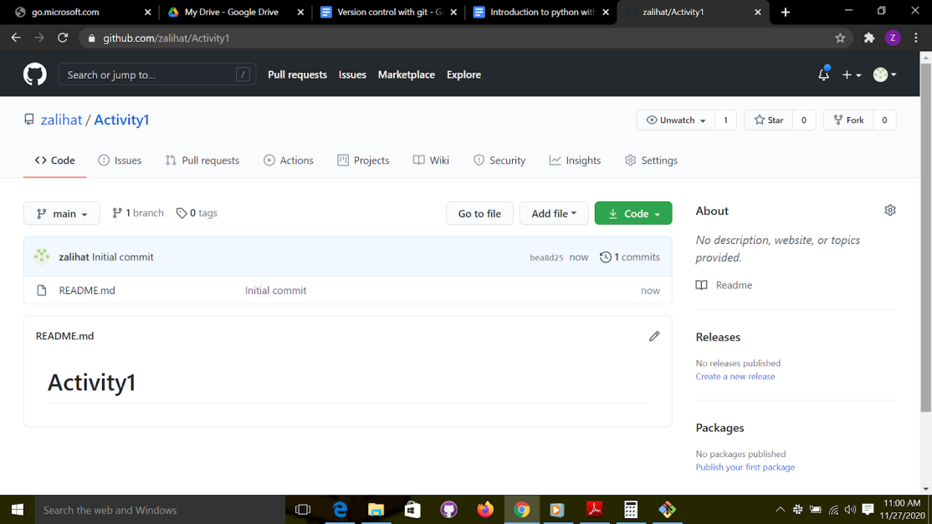

Figure 53:  Created repository’s page

8. To link both repositories. Copy the remote repository’s url. Click on code, and copy the link

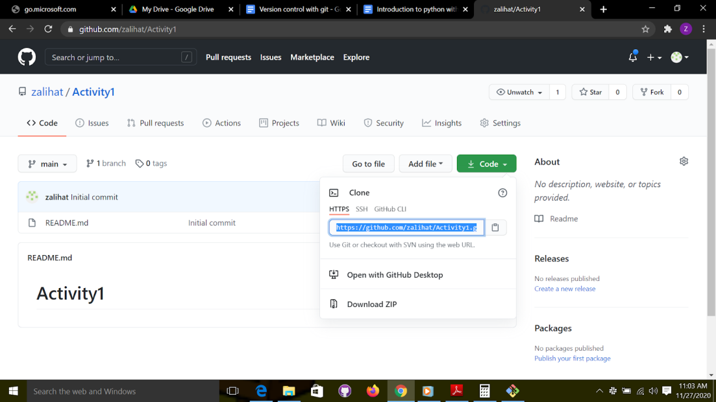

Figure 54: copy remote repository’s url

Go back to "git bash" and run

Git remote

This will return nothing, because we don't have any remote repository linked yet, to link the repository run the command

Git remote add origin [url]

To paste the url, use the insert key on your keyboard.

Make sure you copy the url, then type git remote, add origin, then press  insert key.

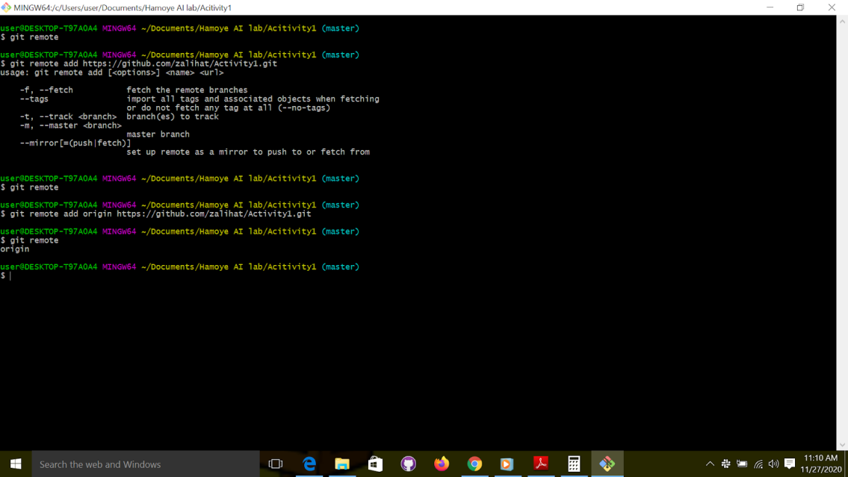

Figure 55: git remote command

9. “Git push” to push changes to the remote repository.

git push origin master

Figure 56: Push changes to the remote repository.

10. Compare and pull request;

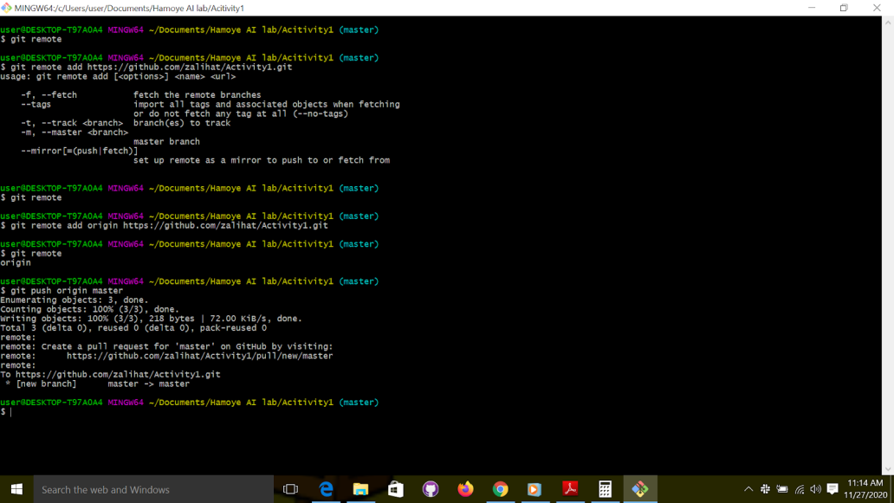

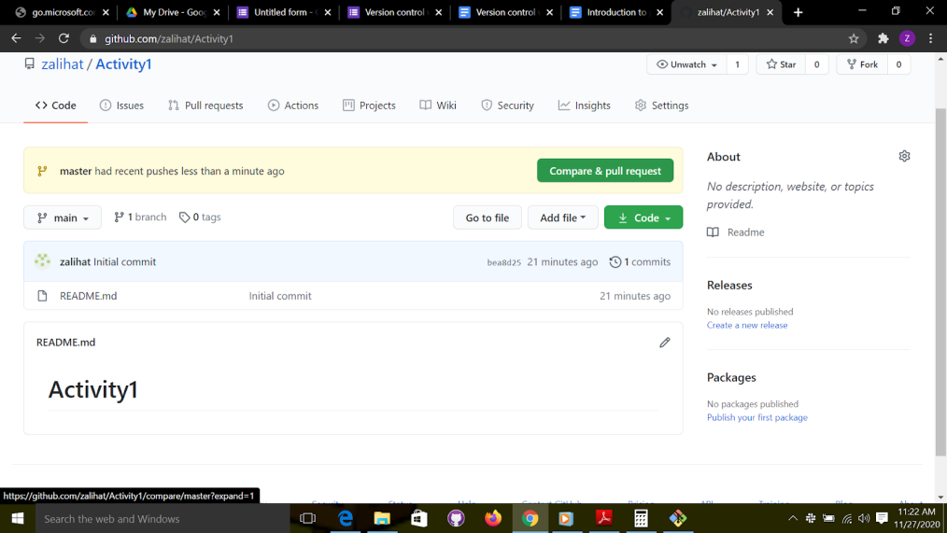

Figure 57: compare changes and create a pull request.

11. As shown above, the changes are not reflecting because the branch we pushed to was master not main. Hence, just click on  “main “and change it to “master” as shown below;

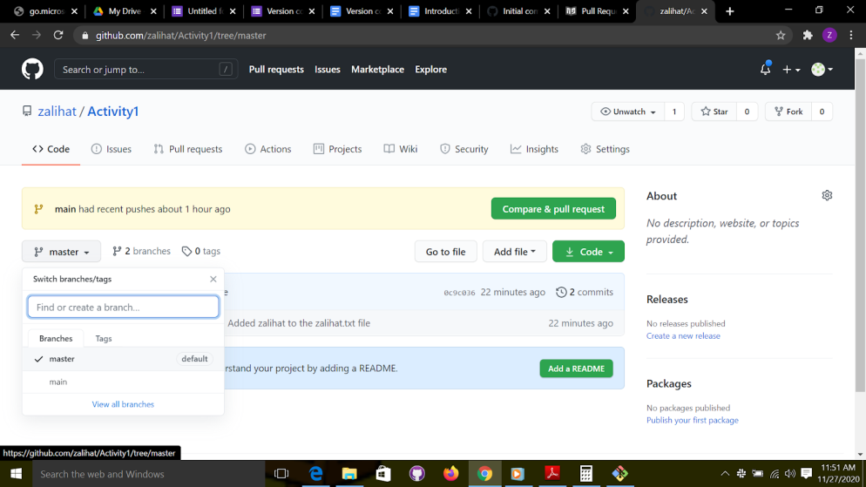

Figure 58: switch from branch “main” to branch “master”

Copy the link to your repository as shown below;

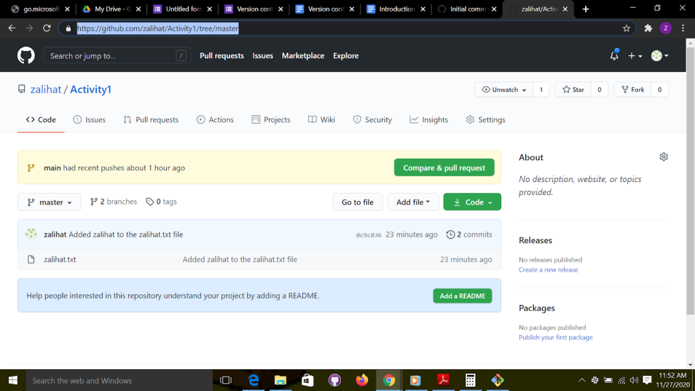

Figure 59: copy remote repository’s url.

Congratulations, you have successfully created a local repository, made changes to it, created a remote repository, linked it to the local repository, and pushed your changes to the remote repository. Now you can share your code with friends by just copying the link to the repository. Easy, yeah? Copy the link to your repo and share it with me. Note that this is not compulsory.

Link for submission -

<https://forms.gle/sskJwgu2zkeuSkQ37>

**Project 2**

For the second activity you will contribute to a project. Here is the link to the repository, <https://github.com/HamoyeHQ/Version-ctrl-with-git.git>

1. Fork the repository.
2. Clone the repository, so you can have a copy of the repository on your local machine.
3. Create a new branch
4. Contribute
5. Stage changes
6. Commit changes
7. Create a pull request (PR)

Solution

1. To "fork" the repository, go to the repository, click on "fork" and select which account to copy the repository to.

2. Copy the link to your version of the repository.

3. To clone the repository, go to the folder where you want the repository to be copied to and "git bash" here. Then run the command to clone a repository.

**git clone url**

4. Close the "git bash", open the cloned repository and do "git bash" here.

5. Create a branch. You can name the branch anything, but it’s preferable to use your name. You can do this by running the command;

**git branch branchname**

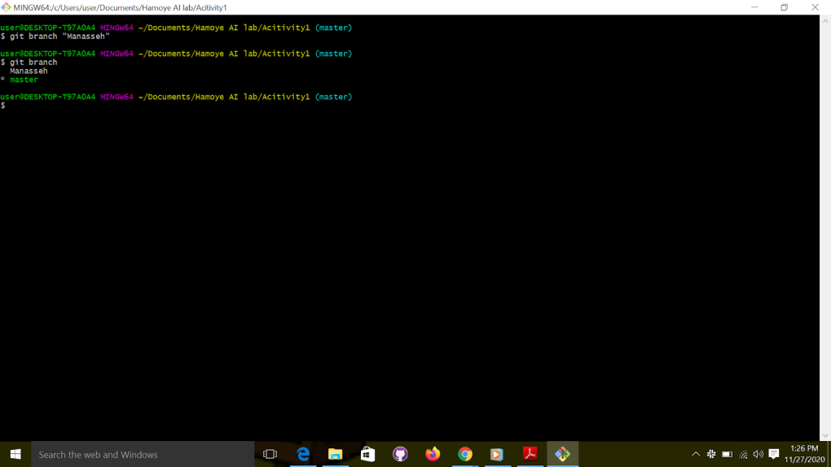

Figure 60: create the branch

6. Switch to the new branch using the git checkout command;

Git checkout branch name

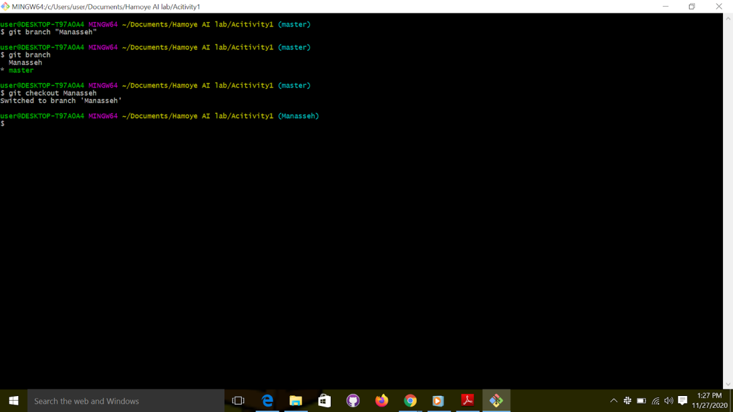

Figure 61: switching to the new branch

7. Edit the attendance.txt file using any text editor. Add your name to the list of names. Save and exit.

8. “git  add” to stage the changes

“git add. “

9. “Git commit” to commit the changes,

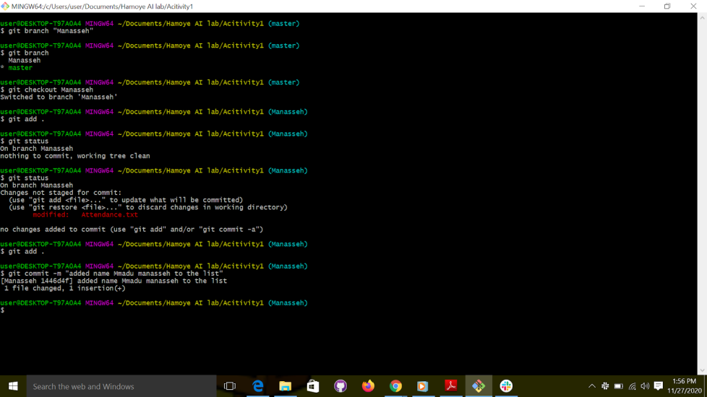

Figure 62: make changes to the repository, stage and commit changes.

10. Switch to the master branch

**git checkout master.**

11. Pull changes so that your copy can be up to date with the remote repository.

**Git pull origin master**

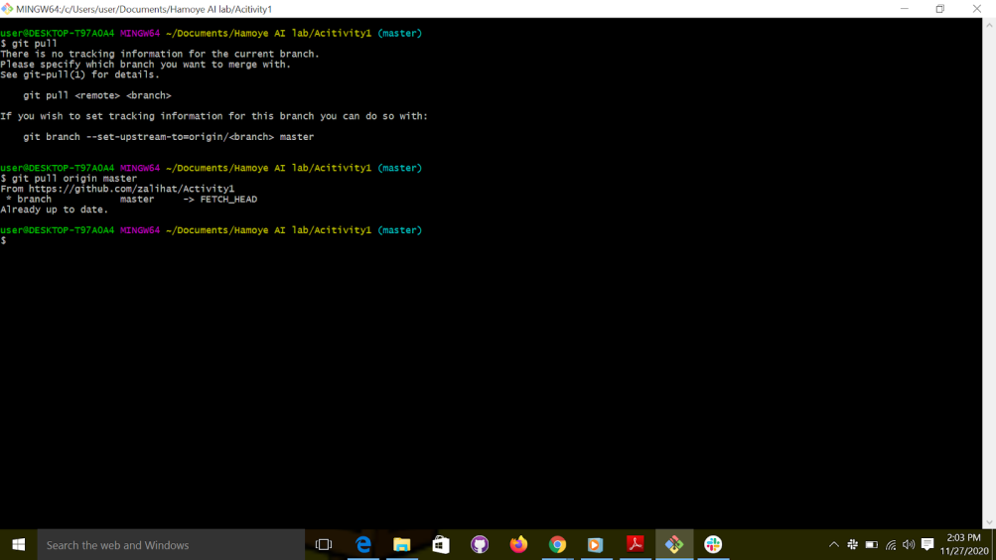

Figure 63: Pull changes

12. Push your branch to the remote repository.

First switch back to your new branch

Then push

**Git push -u origin branch name**

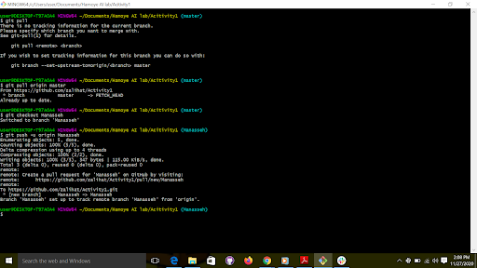

Figure 64: push changes to the local repository.

Yes, we just pushed to the remote repository, but we need to create a PR to notify the owner of the repository that we want to make changes,

13. Make a Pull request (PR).

If you check the message after the push command, you will get the link to create the pull. For example,

<https://github.com/zalihat/Version-ctrl-with-git/pull/new/attendance>

14. Follow the link to create a PR

The link will look like this;

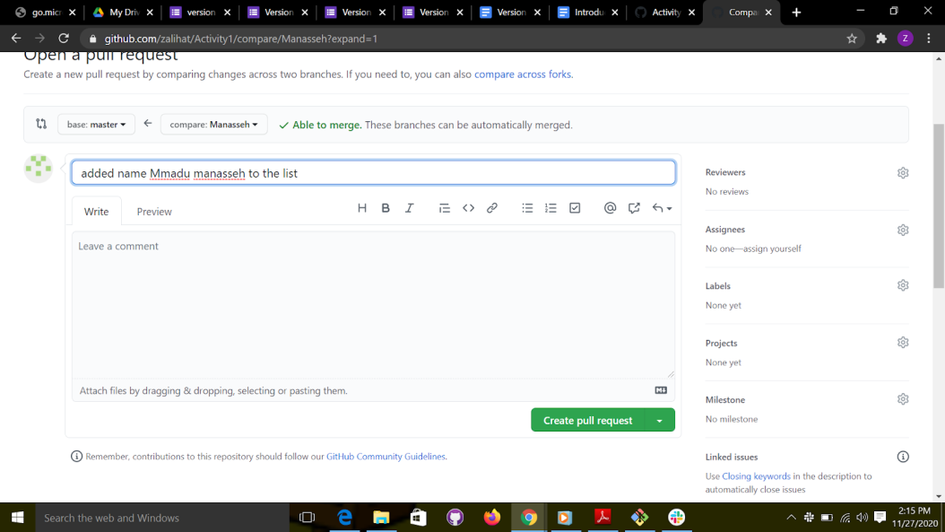

Figure 65: Create  a pull request.

Create the Pull request and wait for the reviewer to merge your pull request.

You will get a notification once your pull request has been merged.

Congratulations, you have successfully contributed to another person’s repo. This is how you contribute to open source projects.